
HASSAN II UNIVERSITY OF CASABLANCA
Faculty of Sciences Aïn Chock – FSAC
Laboratory of Data Engineering and Intelligent Systems – LIDSI
Master's Degree – Intelligent Systems Engineering

FINAL YEAR PROJECT

Architecture and Security Mechanisms for the Deployment of Intelligent Agents:
Implementation and Evaluation through Scenarios

Topics: Agentic AI • Cybersecurity • Supervision • Control • Risk Management

Academic Year 2025–2026

Prepared by:  HARIMECH SIHAM | Supervised by:  Prof. Said JAI ANDALOUSSI  Prof. Laila FETJAH  Prof. Mohamed ERRAIS

Dedication

I dedicate this work to my family, whose love, support, and sacrifices have been the foundation of every achievement in my life.
To my mother, whose unwavering encouragement, patience, and unconditional love have always given me the strength to move forward, even during the most challenging moments.
To my father, for his efforts and support throughout my educational journey.
To all those who believed in me, my friends who encouraged me, and inspired me to pursue my goals with determination and perseverance.
Finally, I dedicate this work to myself, in recognition of the effort, resilience, and commitment invested throughout this journey. Completing this master’s degree is not only an academic achievement but also a testament to personal growth, dedication, and the belief that hard work always bears fruit.

Acknowledgements

First and foremost, I would like to express my sincere gratitude to Almighty God for granting me the strength, patience, and determination to successfully complete this work.
I would like to extend my deepest thanks to my supervisors, Prof. Said Jai Andaloussi, Prof. Laila Fetjah, and Prof. Mohamed Errais, for their valuable guidance, constructive advice, and continuous support throughout the realization of this project. Their expertise and encouragement greatly contributed to the successful completion of this work.
I would also like to thank the Faculty of Sciences Aïn Chock (FSAC), the Laboratory of Data Engineering and Intelligent Systems (LIDSI), and all the professors of the master’s program in Intelligent Systems Engineering for the quality of education and knowledge they have provided throughout my academic journey.
My sincere appreciation also goes to my family for their constant support, understanding, and encouragement during the preparation of this thesis.
Finally, I would like to thank all my friends, classmates, and colleagues who, directly or indirectly, contributed to the completion of this project through their support, advice, and encouragement.
To all of them, I express my heartfelt gratitude.

Abstract

The rapid emergence of Agentic Artificial Intelligence is transforming the way modern computer systems operate. Autonomous agents capable of perceiving their environment, reasoning, making decisions, and interacting with external digital services are increasingly being deployed in critical domains such as cybersecurity, healthcare, finance, and industrial automation. While this autonomy offers significant advantages in terms of efficiency and automation, it also introduces new security challenges, including unauthorized actions, privilege escalation, prompt injection attacks, and loss of operational control.
This master’s thesis addresses these challenges through the design, implementation, and evaluation of a secure architecture for the controlled deployment of a multi-agent system. The proposed prototype integrates five intelligent agents with distinct responsibilities and incorporates a comprehensive security framework based on Role-Based Access Control (RBAC), behavioral anomaly detection, automated incident response, and centralized audit logging. These mechanisms are designed according to a Security-by-Design approach to ensure that every agent action is monitored, validated, and traceable.
The proposed architecture is evaluated through four representative scenarios: normal system operation, unauthorized action attempts, behavioral anomalies, and interactions with malicious inputs simulating prompt injection attacks. The experimental results demonstrate the effectiveness of the proposed security mechanisms in detecting, blocking, and logging suspicious activities while maintaining normal system functionality. Furthermore, the study highlights the feasibility of integrating security controls directly into agentic systems and provides a foundation for future research on secure autonomous agents.
Future work includes the integration of machine learning–based anomaly detection techniques, hybrid RBAC–ABAC access control models, and advanced trust mechanisms for inter-agent communication.
Keywords: Agentic Artificial Intelligence, Multi-Agent Systems, Cybersecurity, Role-Based Access Control (RBAC), Agent Security, Behavioral Anomaly Detection, Incident Management, Audit Logging, Python, MongoDB, LangChain.

Résumé (French)

L’émergence rapide de l’intelligence artificielle agentique transforme profondément le fonctionnement des systèmes informatiques modernes. Les agents autonomes, capables de percevoir leur environnement, de raisonner, de prendre des décisions et d’interagir avec des services numériques externes, sont de plus en plus déployés dans des domaines critiques tels que la cybersécurité, la santé, la finance et l’automatisation industrielle. Si cette autonomie offre des avantages considérables en matière d’efficacité et d’automatisation, elle introduit également de nouveaux défis de sécurité, notamment les actions non autorisées, l’escalade de privilèges, les attaques par injection de prompt et la perte de contrôle opérationnel.
Ce mémoire de Master s’inscrit dans cette problématique et propose la conception, l’implémentation et l’évaluation d’une architecture sécurisée pour le déploiement contrôlé d’un système multi-agents. Le prototype développé intègre cinq agents intelligents aux responsabilités distinctes et repose sur un cadre de sécurité complet comprenant un contrôle d’accès basé sur les rôles (RBAC), un mécanisme de détection d’anomalies comportementales, une gestion automatisée des incidents ainsi qu’un système centralisé de journalisation et d’audit. Ces mécanismes sont conçus selon une approche Security by Design afin de garantir que chaque action effectuée par un agent soit contrôlée, validée et traçable.
L’architecture proposée est évaluée à travers quatre scénarios représentatifs : le fonctionnement normal du système, les tentatives d’actions non autorisées, les comportements anormaux des agents et les interactions avec des entrées malveillantes simulant des attaques par injection de prompt. Les résultats obtenus démontrent l’efficacité des mécanismes de sécurité mis en œuvre pour détecter, bloquer et enregistrer les activités suspectes tout en préservant le bon fonctionnement du système. Cette étude met également en évidence la faisabilité de l’intégration de contrôles de sécurité directement au sein des systèmes agentiques et constitue une base solide pour de futures recherches sur la sécurisation des agents autonomes.
Les perspectives incluent l’intégration de techniques de détection d’anomalies basées sur l’apprentissage automatique, l’adoption d’un modèle hybride RBAC–ABAC ainsi que la mise en place de mécanismes avancés de confiance pour les communications inter-agents.
Mots-clés : Intelligence Artificielle Agentique, Systèmes Multi-Agents, Cybersécurité, Contrôle d’Accès Basé sur les Rôles (RBAC), Sécurité des Agents, Détection d’Anomalies Comportementales, Gestion des Incidents, Journalisation d’Audit, Python, MongoDB, LangChain.

Table of Contents
Dedication 2
Acknowledgements 3
Abstract 4
Résumé (French) 5
General introduction 11
Chapter 1: State of the Art 13
1.1 Introduction 13
1.2 Large Language Models (LLMs) 15
1.2.1 Evolution of Natural Language Processing 15
1.2.2 Transformer Architecture 16
1.2.3. Modern Large Language Models 17
1.2.4 Core Capabilities of LLMs 18
1.2.5 Retrieval-Augmented Generation (RAG) 19
1.2.6 Limitations of Large Language Models 19
1.2.7 Role of LLMs in Agentic AI 20
1.3 Agentic Artificial Intelligence 20
1.3.1 Definition of Agentic AI 21
1.3.2 Characteristics of Agentic Systems 21
1.3.3 Agent Architectures 22
1.3.4 Agent Lifecycle 24
1.3.5 Applications of Agentic AI 25
1.3.6 Limitations and Challenges 26
1.3.7 Agentic AI and Security 26
1.4 Multi-Agent Systems (MAS) 26
1.4.1 Definition of Multi-Agent Systems 27
1.4.2 Fundamental Properties of Multi-Agent Systems 27
1.4.3 Types of Multi-Agent Systems 29
1.4.4 Communication Models in Multi-Agent Systems 29
1.4.5 Coordination Mechanisms 30
1.4.6 Advantages of Multi-Agent Systems 31
1.4.7 Challenges of Multi-Agent Systems 31
1.4.8 Multi-Agent Systems and Security 32
1.5 Agent Development Frameworks 32
1.5.1 LangChain 33
1.5.2 CrewAI 33
1.5.3 AutoGen 34
1.5.4 LangGraph 35
1.5.5 Comparative Analysis of Agent Frameworks 36
1.5.6 Framework Selection for the Proposed System 36
1.6 Access Control Models 37
1.6.1 Discretionary Access Control (DAC) 38
1.6.2 Mandatory Access Control (MAC) 38
1.6.3 Attribute-Based Access Control (ABAC) 39
1.6.4 Role-Based Access Control (RBAC) 40
1.6.5 Comparative Analysis of Access Control Models 42
1.6.6 Justification of RBAC Selection 42
1.7 Security Risks in Agentic Systems 43
1.7.1 Risk Taxonomy for Agentic AI 44
1.7.2 Prompt Injection Attacks 45
1.7.3 Excessive Agency 45
1.7.4 Tool Misuse and Unauthorized Actions 46
1.7.5 Data Leakage 47
1.7.6 Memory Poisoning 47
1.7.7 Behavioral Drift and Anomalous Behavior 48
1.7.8 Inter-Agent Attacks 48
1.7.9 Security Challenges for Multi-Agent Systems 49
1.7.10 Summary 49
1.8 Security-by-Design for Agentic AI 49
1.8.1 Principle of Least Privilege 50
1.8.2 Defense in Depth 50
1.8.3 Audit Logging and Traceability 50
1.8.4 Behavioral Monitoring and Anomaly Detection 51
1.8.5 Incident Response 51
1.9 Related Work and Research Gap 52
1.10 Research Gap 52
1.11 Conclusion 53
Chapter 2: Requirements Analysis 53
2.1 Introduction 53
2.2 Project Context and Objectives 54
2.2.1 Problem Statement 54
2.2.2 Project Objectives 54
2.3 Stakeholders and System Actors 55
2.3.1 Human Administrator 55
2.3.2 Intelligent Agents 55
2.4 Functional Requirements 55
2.5 Non-Functional Requirements 57
2.6 Security Requirements 58
2.7 System Constraints 59
2.8 Evaluation Scenarios 59
2.9 Conclusion 60
Chapter 3: System Architecture and Design 60
3.1 Introduction 60
3.2 Global Overview 61
3.3 Detailed Module Description 62
3.3.1 Agent Module 62
3.3.2 Control Module 63
3.3.3 Supervision Module 63
3.3.4 Detection Module 63
3.3.5 Incident Management Module 63
3.4 Python Project Structure 64
3.5 UML Modeling 64
3.5.1 Use Case Diagram 64
3.5.2 Component Diagram 65
3.5.3 Sequence Diagram 66
3.5.4 Class Diagram 68
3.5.5 Activity Diagram 69
3.6 Conclusion 70
Chapter 4: Implementation of the Proposed System 70
4.1 Introduction 70
4.2 RBAC Model — Roles and Permissions 71
4.3 Pre-Execution Control 72
4.4 Anomaly Detection Rules 73
4.5 Incident Response Policies 73
Chapter 5: Testing, Results and Evaluation 75
5.1 Introduction 75
5.2 Evaluation Environment and Method 75
5.3 Scenario Evaluation 75
5.3.1 Scenario 1 - Normal Operation 75
5.3.2 Scenario 2 - Forbidden Action 75
5.3.3 Scenario 3 - Behavioral Drift 75
5.3.4 Scenario 4 - Malicious Input 76
5.3.5 Scenario 5 - Role Identity Inconsistency 76
5.4 Dashboard and Traceability Validation 76
5.5 Requirement Coverage 76
5.6 Conclusion 77
Chapter 6: General Conclusion and Perspectives 78
6.1 General Conclusion 78
6.2 Main Contributions 78
6.3 Limitations 78
6.4 Future Perspectives 79
Bibliographic References 80

List of Figures
Figure 1.1: RBAC description 41
Figure 1.2: NIST RBAC Levels 42
Figure 3.1: Overview of the project 62
Figure 3.2: Use case diagram 65
Figure 3.3: Component diagram 66
Figure 3.4: Sequence Diagram — Scenario 1: Normal flow 67
Figure 3.5: Sequence diagram — Scenario 2: Forbidden action flow 67
Figure 3.6: Sequence Diagram — Scenario 3: Incident flow 68
Figure 3.7: Sequence Diagram — Scenario 4: Malicious external input 68
Figure 3.8: Class Diagram 69
Figure 3.9: Activity Diagram 70

List of Tables
Table 1.1: GPT distribution 18
Table 1.2: Comparative Analysis of Agent Development Framework 37
Table 1.3: Comparative Analysis of Access Control Models 43
Table 1.4: Summary of Related Work 52
Table 2.1: Functional Requirements 56
Table 2.2: Non-Functional Requirements 57
Table ‎2.3: Security Requirements 59
Table 2.4: Evaluation Scenarios 60
Table ‎3.1: Project structure 64
Table 4.1: RBAC roles 72
Table 4.2: Execution control process 73
Table 4.3: Anomaly detection rules 73
Table ‎4.4: Incident responses 74

General introduction

Artificial Intelligence (AI) has experienced remarkable growth over the last decade, driven by advances in machine learning, deep learning, and more recently, Large Language Models (LLMs). These technologies have enabled the development of increasingly sophisticated systems capable of understanding natural language, generating content, reasoning about complex problems, and assisting users in a wide range of tasks. As AI capabilities continue to evolve, a new paradigm known as Agentic Artificial Intelligence has emerged, extending traditional AI systems beyond simple response generation toward autonomous decision-making and action execution.
Agentic AI systems are composed of intelligent agents capable of perceiving their environment, maintaining memory, planning actions, interacting with external tools, and collaborating with other agents to achieve complex objectives. Frameworks such as LangChain, CrewAI, LangGraph, and AutoGen have significantly accelerated the adoption of this paradigm by providing developers with the ability to build autonomous and collaborative multi-agent systems. These systems are increasingly being deployed in critical domains including cybersecurity, healthcare, finance, customer service, and industrial automation.
Despite their numerous advantages, autonomous agents introduce significant security challenges. Unlike traditional software applications, agentic systems possess the ability to make decisions and execute actions with limited or no direct human intervention. Consequently, vulnerabilities such as unauthorized access, privilege escalation, prompt injection attacks, malicious tool usage, data leakage, and uncontrolled agent behavior can lead to serious operational and security risks. As organizations move toward integrating autonomous agents into real-world environments, ensuring their security, accountability, and controllability has become a major research and industrial concern.
In response to these challenges, this master’s thesis focuses on the design and implementation of a secure architecture for the controlled deployment of intelligent agents. The proposed solution aims to establish a security framework capable of monitoring agent activities, enforcing access control policies, detecting abnormal behaviors, and responding automatically to potential incidents. The architecture adopts a Security-by-Design approach, ensuring that security mechanisms are integrated into the system from the earliest stages of development rather than being added as an afterthought.
The developed prototype consists of five intelligent agents with distinct responsibilities operating within a controlled multi-agent environment. To secure their interactions and actions, several complementary security mechanisms are implemented, including a Role-Based Access Control (RBAC) model, a behavioral anomaly detection module, an incident management component, and a centralized audit logging system. Together, these mechanisms provide visibility, traceability, and control over the actions performed by autonomous agents.
The main objective of this work is to demonstrate that the deployment of autonomous agents can be achieved in a secure and controlled manner through the integration of appropriate governance and monitoring mechanisms. More specifically, this project seeks to:
- Design a modular and secure multi-agent architecture;
- Implement role-based access control policies to regulate agent permissions;
- Detect suspicious or abnormal agent behaviors;
- Provide automated responses to security incidents;
- Ensure complete traceability of agent activities through audit logs;
- Evaluate the effectiveness of the proposed approach through representative security scenarios.
To validate the proposed architecture, a prototype was developed using Python and modern AI-agent development frameworks. The evaluation is conducted through five practical scenarios covering normal operation, unauthorized actions, behavioral drift, malicious input, and inconsistency between an agent’s registered identity and its claimed role. The results obtained allow the assessment of the effectiveness of the implemented security mechanisms and highlight the importance of integrating security controls directly into agentic systems.
This report is organized as follows:
- Chapter 1 presents the state of the art related to Agentic AI, Multi-Agent Systems, access control models, and security challenges associated with autonomous agents.
- Chapter 2 describes the requirements analysis, including the functional and non-functional requirements of the proposed system.
- Chapter 3 details the design of the proposed architecture, its components, database structure, and UML models.
- Chapter 4 presents the implementation of the system, including the development of intelligent agents and security modules.
- Chapter 5 describes the testing and evaluation process through five security scenarios and discusses the observed results.
- Chapter 6 concludes the thesis by summarizing the main contributions, discussing limitations, and presenting future research perspectives.
Through this work, we aim to contribute to the growing field of secure Agentic AI by proposing a practical and extensible framework that combines autonomous agent capabilities with robust security and governance mechanisms.

Chapter 1: State of the Art

1.1 Introduction
Artificial Intelligence (AI) has experienced unprecedented growth over the past decade, driven by major advances in machine learning, deep learning, and, more recently, Large Language Models (LLMs). These technologies have significantly expanded the capabilities of intelligent systems, enabling them to understand natural language, generate human-like content, perform complex reasoning tasks, and support decision-making processes across a wide range of application domains. As a result, AI has become a strategic technology adopted in sectors such as healthcare, finance, cybersecurity, education, transportation, and industrial automation.
The emergence of Large Language Models such as GPT, Claude, Gemini, and Llama has marked a significant milestone in the evolution of artificial intelligence. Unlike traditional AI systems that are designed to perform a single specialized task, modern LLMs can execute a variety of cognitive activities, including question answering, text summarization, code generation, data analysis, and conversational assistance. Their ability to interact naturally with users has accelerated the integration of AI into both consumer and enterprise applications.
Despite these remarkable capabilities, traditional LLM-based systems remain fundamentally reactive. They generate responses based on user prompts but generally lack autonomy, long-term planning capabilities, persistent memory, and the ability to independently interact with external environments. To overcome these limitations, a new paradigm known as Agentic Artificial Intelligence (Agentic AI) has emerged. Agentic AI extends the capabilities of LLMs by integrating reasoning mechanisms, memory management, planning strategies, and tool utilization, enabling intelligent agents to autonomously pursue objectives and execute complex multi-step tasks.
Agentic AI systems are increasingly implemented through Multi-Agent Systems (MAS), where multiple specialized agents collaborate to solve problems that exceed the capabilities of a single agent. In such environments, each agent is assigned a specific role and responsibility, while communication and coordination mechanisms allow them to collectively achieve common objectives. This approach offers significant advantages in terms of scalability, modularity, task specialization, and operational efficiency. Consequently, multi-agent architecture is becoming increasingly popular in domains such as cybersecurity operations centers, intelligent assistants, autonomous business workflows, and industrial control systems.
However, the growing autonomy of intelligent agents introduces new security concerns. Unlike conventional software applications, autonomous agents possess the ability to make decisions, invoke external tools, access sensitive resources, and execute actions without direct human intervention. This increased level of autonomy expands the attack surface of information systems and creates opportunities for novel threats, including prompt injection attacks, unauthorized access, privilege escalation, data leakage, malicious tool exploitation, and uncontrolled agent behavior. Security incidents involving autonomous agents may have severe consequences, particularly when deployed in critical infrastructures or decision-support environments.
Recent studies conducted by organizations such as the National Institute of Standards and Technology (NIST), the Open Worldwide Application Security Project (OWASP), and leading AI research institutions have highlighted the urgent need for dedicated security frameworks capable of governing and supervising autonomous agents. Existing agent development frameworks primarily focus on functionality, orchestration, and performance, while security mechanisms often remain limited or are treated as secondary concerns. This imbalance creates a significant gap between the rapid adoption of Agentic AI and the maturity of the security controls required to manage associated risks.
To address these challenges, this chapter presents a comprehensive review of the scientific and technical literature related to Agentic Artificial Intelligence, Multi-Agent Systems, access control models, and security mechanisms applicable to intelligent agents. The objective is to establish the theoretical foundations necessary for the design of a secure multi-agent architecture and to identify the main challenges that must be addressed when deploying autonomous agents in controlled environments.
The chapter is organized as follows. Section 1.2 introduces Large Language Models and their role as the cognitive foundation of modern intelligent agents. Section 1.3 presents the concept of Agentic AI and the principal architecture used to implement autonomous agents. Section 1.4 explores Multi-Agent Systems and their coordination mechanisms. Section 1.5 analyzes the most widely used agent development frameworks. Section 1.6 examines the principal access control models and justifies the selection of the RBAC model for this project. Section 1.7 discusses the major security risks associated with intelligent agents, while Section 1.8 presents the Security-by-Design principles applicable to agentic systems. Finally, Sections 1.9 and 1.10 review related work and identify the research gap addressed by the proposed architecture.

1.2 Large Language Models (LLMs)
Large Language Models (LLMs) represent one of the most significant advances in Artificial Intelligence in recent years. Built upon deep learning techniques and trained on massive collections of textual data, these models have demonstrated remarkable capabilities in natural language understanding, text generation, reasoning, translation, summarization, question answering, and software development assistance. Their emergence has transformed the field of Natural Language Processing (NLP) and laid the foundation for the development of modern intelligent agents.
Unlike traditional rule-based systems, LLMs learn statistical patterns directly from data, enabling them to generalize across a wide variety of tasks without requiring task-specific programming. This flexibility has made them the core component of most Agentic AI systems, where they serve as the reasoning and decision-making engine responsible for interpreting goals, generating plans, and interacting with external tools.
The development of LLMs is the result of decades of research in Natural Language Processing, machine learning, and neural network architecture. Understanding their evolution and underlying mechanisms is essential for analyzing both the capabilities and limitations of modern intelligent agents.
1.2.1 Evolution of Natural Language Processing
Natural Language Processing (NLP) has evolved through several generations of approaches.
Rule-Based Systems
The earliest NLP systems relied on manually defined linguistic rules and dictionaries. These systems attempted to model language through grammatical structures and predefined vocabularies. Although effective in limited domains, they suffered from poor scalability and required extensive human effort to maintain.
Examples include ELIZA (1966) and SHRDLU (1970), which demonstrated the possibility of human-computer interaction through natural language. However, their inability to adapt to linguistic variability significantly limited their practical applicability.
Statistical NLP
During the 1990s and early 2000s, statistical methods became dominant. Instead of relying solely on handcrafted rules, these approaches learned language patterns from large datasets.
Common techniques included:
- Hidden Markov Models (HMM)
- Naïve Bayes Classifiers
- Conditional Random Fields (CRF)
- N-gram Language Models
Although these methods significantly improved performance, they remained limited in their ability to capture long-range semantic dependencies and contextual information.
Deep Learning Revolution
The introduction of deep neural networks transformed NLP. Architectures such as Recurrent Neural Networks (RNNs), Long Short-Term Memory Networks (LSTMs), and Gated Recurrent Units (GRUs) enabled models to learn contextual information more effectively.
However, these architectures suffered from several limitations, including sequential processing constraints, vanishing gradients, and difficulties in handling very long sequences. These challenges motivated the development of a more scalable architecture: the Transformer.
1.2.2 Transformer Architecture
The publication of the paper Attention Is All You Need by Vaswani et al. (2017) marked a turning point in Artificial Intelligence. The authors introduced the Transformer architecture, which became the foundation of virtually all modern Large Language Models.
Unlike recurrent architectures, Transformers process entire sequences simultaneously through a mechanism known as self-attention.
Self-Attention Mechanism
Self-attention enables a model to determine which words in a sentence are most relevant when processing a particular token.
For example, in the sentence:
"The agent executed the action because it received permission."
The model learns that the pronoun "it" refers to "the agent".
This mechanism allows the model to capture contextual relationships over long distances and significantly improves language understanding.
Main Components of a Transformer
The Transformer architecture consists of several key components:
Input Embeddings
Words are converted into dense numerical vectors representing semantic information.
Positional Encoding
Since Transformers process words simultaneously rather than sequentially, positional encoding provides information about word order within a sentence.
Multi-Head Attention
Multiple attention mechanisms operate in parallel, enabling the model to analyze relationships from different perspectives.
Feed-Forward Neural Networks
These layers process information extracted by the attention mechanism and contribute to knowledge representation.
Residual Connections and Layer Normalization
These mechanisms improve training stability and enable the construction of extremely deep neural networks.
Transformer architecture offers three major advantages:
- Efficient parallel processing.
- Improved contextual understanding.
- Exceptional scalability.
These characteristics enabled the development of models containing hundreds of billions of parameters.
1.2.3. Modern Large Language Models
The transformer architecture gave rise to a new generation of language models characterized by unprecedented scale and performance.
GPT Family
The Generative Pre-trained Transformer (GPT) family, developed by OpenAI, is among the most influential LLM families.
Model | Release Year
GPT | 2018
GPT-2 | 2019
GPT-3 | 2020
GPT-4 | 2023
GPT-4o | 2024
GPT-4.5 | 2025
GPT-5 Series | 2025 - 2026
Table 1.1: GPT distribution
The evolution of the GPT family illustrates the rapid progression of Large Language Models from text generation systems toward increasingly capable multimodal and agent-oriented architectures. Recent generations emphasize advanced reasoning, tool integration, extended context windows, and support for autonomous workflows, making them particularly suitable for Agentic AI applications.
Claude
Developed by Anthropic, Claude emphasizes safety, alignment, and Constitutional AI principles.
Its main characteristics include:
- Strong reasoning capabilities
- Large context windows
- Enhanced safety controls
- Reduced harmful outputs
Gemini
Developed by Google DeepMind, Gemini is a multimodal model capable of processing:
- Text
- Images
- Audio
- Video
- Source code
Its architecture is designed to support complex reasoning and enterprise-level applications.
Llama
Developed by Meta AI, the Llama family is notable for its open-weight approach, enabling organizations to deploy advanced language models locally.
Advantages include:
- Lower deployment costs
- Greater customization
- Enhanced privacy
- On-premise deployment
Open-source models such as Llama have accelerated innovation within the Agentic AI ecosystem.
1.2.4 Core Capabilities of LLMs
Modern Large Language Models provide several capabilities that make them suitable for intelligent agents.
Natural Language Understanding
LLMs can interpret complex instructions and infer user intentions.
Text Generation
They can generate coherent, contextually relevant, and human-like content.
Reasoning
Advanced models demonstrate:
- Logical reasoning
- Mathematical reasoning
- Code generation
- Decision support
Knowledge Retrieval
Although not databases, LLMs contain vast amounts of information acquired during training.
Tool Integration
Modern models can interact with:
- APIs
- Databases
- Search engines
- Calculators
- External applications
This capability is fundamental for Agentic AI systems.
1.2.5 Retrieval-Augmented Generation (RAG)
One major limitation of LLMs is that their knowledge is frozen at training time. Retrieval-Augmented Generation (RAG) addresses this problem by combining language models with external knowledge sources.
The RAG process typically consists of four stages:
- User query submission.
- Retrieval of relevant documents from a knowledge base.
- Injection of retrieved information into the prompt.
- Generation of a grounded response.
The main benefits of RAG include:
- Access to up-to-date information.
- Reduction of hallucinations.
- Improved factual accuracy.
- Better domain specialization.
Consequently, RAG has become a standard architecture in enterprise AI applications.
1.2.6 Limitations of Large Language Models
Despite their impressive capabilities, LLMs present several important limitations.
Hallucinations
Models may generate plausible but factually incorrect information.
Lack of True Understanding
LLMs learn statistical relationships rather than possessing genuine understanding.
Context Window Constraints
Although context windows continue to increase, they remain finite.
Knowledge Obsolescence
Information acquired during training may become outdated.
Security Vulnerabilities
LLMs remain vulnerable to:
- Prompt injection attacks
- Jailbreaking attempts
- Data leakage
- Adversarial inputs
These vulnerabilities become particularly problematic when models are granted access to external tools.
High Computational Cost
Training and operating large-scale models require substantial computational resources and energy consumption.
1.2.7 Role of LLMs in Agentic AI
Large Language Models constitute the cognitive foundation of modern intelligent agents. In Agentic AI systems, the LLM acts as the reasoning engine responsible for interpreting objectives, planning actions, selecting tools, analyzing observations, and generating responses.
However, the limitations and security vulnerabilities of LLMs imply that additional governance mechanisms must be implemented before autonomous deployment. Consequently, while LLMs provide the intelligence required for agent autonomy, they must be complemented by access control policies, supervision mechanisms, anomaly detection systems, and security controls capable of preventing misuse and ensuring safe operation.
This observation naturally leads to the emergence of Agentic Artificial Intelligence, which extends traditional LLM capabilities through memory, planning, tool usage, and autonomous decision-making mechanisms. The next section therefore presents the concept, characteristics, and architecture of Agentic AI systems.

1.3 Agentic Artificial Intelligence
The emergence of Large Language Models (LLMs) has significantly expanded the capabilities of Artificial Intelligence systems. However, despite their remarkable performance in natural language understanding and generation, traditional LLMs remain fundamentally reactive: they generate responses to user prompts but generally lack the ability to autonomously pursue objectives, plan actions, interact with external environments, and adapt their behavior over time. To address these limitations, a new paradigm known as Agentic Artificial Intelligence (Agentic AI) has emerged.
Agentic AI combines the reasoning capabilities of Large Language Models with additional components such as memory, planning mechanisms, tool utilization, and autonomous decision-making. This combination enables intelligent systems to move beyond simple conversational interactions and actively perform complex tasks while pursuing predefined goals. As a result, Agentic AI is increasingly recognized as one of the most promising directions in the evolution of artificial intelligence and autonomous systems.
1.3.1 Definition of Agentic AI
An intelligent agent is generally defined as an autonomous software entity capable of perceiving its environment, processing information, making decisions, and performing actions to achieve specific objectives (Russell & Norvig, 2021) [1].
According to Russell and Norvig, an agent can be described as any system that perceives its environment through sensors and acts upon that environment through effectors.
Agentic AI extends this traditional definition by integrating Large Language Models into the agent architecture. Instead of merely responding to isolated prompts, an agentic system can understand high-level objectives, decomposing them into sub-tasks, selecting appropriate actions, utilizing external tools, and adapting its behavior according to feedback received from the environment.
For example, while a traditional chatbot may answer the question:
"What is the weather today?"
an intelligent agent can autonomously:
- Access a weather API.
- Retrieve current weather information.
- Analyze the forecast.
- Schedule notifications if severe weather conditions are detected.
- Perform follow-up actions without additional user intervention.
This transition from reactive responses to autonomous goal-oriented behavior represents the fundamental distinction between traditional AI assistants and Agentic AI systems.
1.3.2 Characteristics of Agentic Systems
Agentic AI systems possess several characteristics that distinguish them from conventional AI applications.
Autonomy
Autonomy refers to the ability of an agent to operate independently with limited human intervention. Once an objective has been defined, the agent can determine the sequence of actions required to achieve that objective.
Goal-Oriented Behavior
Unlike traditional software that follows predefined instructions, intelligent agents focus on achieving goals. The specific actions performed may vary depending on the current context and available resources.
Reasoning Capability
Agentic systems use LLMs to analyze situations, evaluate alternatives, and select appropriate actions. This reasoning process enables agents to solve complex problems that cannot be addressed through static rules alone.
Planning
Planning enables agents to decompose large objectives into smaller manageable tasks. This capability is essential for executing complex workflows involving multiple steps and dependencies.
Memory
Modern agentic systems frequently incorporate memory mechanisms that allow them to retain information across interactions. Memory may be:
- Short-term memory, used during a specific task.
- Long-term memory, used to store knowledge and previous experiences.
Memory significantly improves contextual understanding and task continuity.
Tool Usage
One of the most powerful features of Agentic AI is the ability to interact with external tools and services. Agents can access:
- Databases
- APIs
- Search engines
- File systems
- Software applications
Tool usage allows agents to interact directly with real-world environments and perform practical tasks.
Adaptability
Agentic systems can modify their behavior according to observations and feedback received from their environment. This adaptability improves robustness and enables continuous improvement during task execution.
1.3.3 Agent Architectures
Several architectures have been proposed to implement intelligent agents. These architectures differ in how they organize reasoning, planning, memory, and action execution.
ReAct (Reason + Act)
ReAct, introduced by Yao et al. (2022), combines reasoning and action execution within a unified framework [2].
The ReAct approach combines:
- Reasoning steps
- Action execution steps
The agent alternates between generating reasoning traces and performing actions through external tools.
A simplified execution cycle follows:
Observation → Reasoning → Action → Observation → Reasoning
Advantages:
- Simple implementation.
- Strong transparency.
- Effective integration with tools.
Limitations:
- Error propagation.
- High dependence on prompt quality.
- Limited long-term planning capabilities.
Despite these limitations, ReAct remains one of the most widely adopted architectures in current agent frameworks.
Plan-and-Execute
The Plan-and-Execute architecture separates planning from execution.
The process generally consists of two phases:
- Planning phase:
  - The agent generates a complete action plan.
- Execution phase:
  - The plan is executed step by step.
This architecture improves task organization and reduces unnecessary reasoning cycles.
Advantages:
- Better handling of complex tasks.
- Reduced computational costs.
- Improved execution consistency.
Limitations:
- Plans may become obsolete if the environment changes.
- Limited adaptability during execution.
Reflexion
Reflexion extends traditional agent architectures by introducing self-evaluation mechanisms [3].
After completing a task, the agent:
- Evaluates its performance.
- Identifies mistakes.
- Stores lessons learned.
- Uses this knowledge during future tasks.
This architecture simulates a form of experiential learning and can improve long-term performance without retraining the underlying language model.
Tree of Thoughts (ToT)
Tree of Thoughts is an advanced reasoning architecture designed to improve decision-making [4].
Instead of following a single reasoning path, the agent explores multiple alternative reasoning branches simultaneously.
The process resembles a decision tree:
- Generate several possible solutions.
- Evaluate each branch.
- Select the most promising option.
Advantages:
- Improved reasoning quality.
- Better performance on complex tasks.
- Enhanced decision-making.
Limitations:
- Increased computational cost.
- Longer execution times.
Tree of Thoughts is particularly useful for strategic planning and complex problem-solving scenarios.
1.3.4 Agent Lifecycle
An intelligent agent typically follows a continuous operational cycle during task execution.
The lifecycle generally includes the following stages:
- Goal Reception
  - The agent receives an objective from a user or another system.
- Planning
  - The objective is to be decomposed into smaller tasks.
- Action Selection
  - The agent determines the next action to perform.
- Tool Execution
  - External resources or tools are invoked.
- Observation
  - The agent analyzes the results of its actions.
- Reasoning
  - New information is evaluated.
- Goal Evaluation
  - The agent determines whether the objective has been achieved.
- Iteration
  - The cycle repeats until completion.
This iterative process enables agents to adapt dynamically to changing environments and unforeseen situations.
1.3.5 Applications of Agentic AI
The growing capabilities of intelligent agents have led to their adoption across numerous domains.
Cybersecurity
Agents can:
- Monitor security events.
- Analyze logs.
- Detect anomalies.
- Respond to incidents.
Healthcare
Agents assist in:
- Medical information retrieval.
- Clinical decision support.
- Administrative automation.
Finance
Applications include:
- Risk analysis.
- Fraud detection.
- Investment support.
- Financial reporting.
Customer Service
Agents provide:
- Automated assistance.
- Ticket management.
- Personalized recommendations.
Software Engineering
Agents can:
- Generate code.
- Review software.
- Create documentation.
- Perform testing activities.
These applications demonstrate the versatility and transformative potential of Agentic AI.
1.3.6 Limitations and Challenges
Despite their advantages, Agentic AI systems face several important challenges.
Hallucinations
Agents may rely on inaccurate information generated by the underlying language model.
Lack of Explainability
The decision-making process of complex agents is often difficult to interpret.
High Computational Requirements
Agent architectures frequently require multiple LLM calls and tool interactions.
Reliability Issues
Errors may propagate through long execution chains.
Security Risks
Autonomous agents may:
- Execute unauthorized actions.
- Access to sensitive information.
- Misuse external tools.
- Become vulnerable to malicious inputs.
These challenges highlight the importance of implementing robust governance and security mechanisms.
1.3.7 Agentic AI and Security
The increasing autonomy of intelligent agents significantly expands the attack surface of modern information systems. Unlike traditional software applications, agentic systems are capable of making decisions, invoking tools, accessing resources, and interacting with external environments with minimal human supervision.
Therefore, new categories of threats emerge, including prompt injection attacks, privilege escalation, unauthorized access, excessive autonomy, data leakage, and malicious tool usage. These risks become even more significant when multiple agents collaborate within a shared environment and exchange information continuously.
Therefore, ensuring the security, accountability, and controllability of intelligent agents has become a major research challenge. Access control mechanisms, behavioral monitoring, anomaly detection, incident response, and comprehensive audit logging are increasingly considered essential components of secure agentic systems.
The complexity of these challenges further increases when several autonomous agents cooperate toward common objectives. Such environments are known as Multi-Agent Systems (MAS) and constitute the focus of the next section.

1.4 Multi-Agent Systems (MAS)
As Agentic Artificial Intelligence continues to evolve, the complexity of tasks assigned to intelligent agents is increasing significantly. While a single agent may be sufficient for simple objectives, many real-world problems require multiple specialized entities working together to achieve a common goal. This need has led to the emergence of Multi-Agent Systems (MAS), a field of Artificial Intelligence focused on the design and coordination of multiple autonomous agents operating within a shared environment.
Multi-Agent Systems represent a natural evolution of Agentic AI by enabling task distribution, specialization, collaboration, and collective decision-making. Rather than relying on a single agent responsible for all operations, MAS architectures distribute responsibilities among several agents, each possessing distinct capabilities and objectives. This approach improves scalability, flexibility, robustness, and efficiency while reducing the complexity associated with monolithic intelligent systems.
Today, Multi-Agent Systems are widely applied in domains such as robotics, cybersecurity, industrial automation, logistics, smart cities, financial trading, and intelligent virtual assistants. The increasing popularity of frameworks such as CrewAI, AutoGen, LangGraph, and LangChain further demonstrates the growing importance of collaborative agent architectures in modern AI ecosystems.
1.4.1 Definition of Multi-Agent Systems
A Multi-Agent System can be defined as a collection of autonomous agents that interact within a shared environment to achieve individual or collective objectives.
According to Wooldridge (2009), a Multi-Agent System consists of multiple intelligent entities capable of:
- Perceiving their environment.
- Making independent decisions.
- Communicating with other agents.
- Coordinating actions.
- Pursuing individual or shared goals.
Each agent possesses a certain degree of autonomy and can operate independently. However, the true strength of a Multi-Agent System emerges from collaboration and information exchange between agents.
For example, in a cybersecurity environment:
- A Collector Agent gathers security logs.
- An Analyst Agent evaluates collected data.
- A Detection Agent identifies suspicious activities.
- An Incident Agent responds to detected threats.
- An Administrator Agent supervises system operations.
Together, these agents perform tasks that would be difficult for a single agent to accomplish efficiently.
1.4.2 Fundamental Properties of Multi-Agent Systems
Multi-Agent Systems are characterized by several fundamental properties.
Autonomy
Each agent can make decisions independently without requiring continuous external control.
Autonomy enables agents to:
- Execute tasks independently.
- React to environmental changes.
- Manage their own internal state.
Specialization
Agents are typically designed to perform specific functions.
Examples include:
- Data collection agents.
- Analysis agents.
- Monitoring agents.
- Reporting agents.
Specialization improves efficiency by allowing each agent to focus on a limited set of responsibilities.
Communication
Agents must exchange information to coordinate their activities.
Communication enables:
- Information sharing.
- Task delegation.
- Coordination of actions.
- Conflict resolution.
Without communication, collaborative behavior would not be possible.
Cooperation
Cooperation occurs when multiple agents work together toward a common objective.
Examples include:
- Collaborative problem solving.
- Distributed data processing.
- Coordinated incident response.
Adaptability
Agents can adjust their behavior according to environmental changes and interactions with other agents.
This capability improves system resilience and operational flexibility.
Distributed Decision-Making
Unlike centralized systems, decision-making is distributed among multiple agents.
Benefits include:
- Improved scalability.
- Reduced bottlenecks.
- Increased fault tolerance.
1.4.3 Types of Multi-Agent Systems
Multi-Agent Systems can be classified according to the nature of interactions between agents.
Cooperative Multi-Agent Systems
In cooperative systems, all agents share common objectives and collaborate to achieve collective goals.
Characteristics:
- Shared information.
- Coordinated decision-making.
- Mutual assistance.
Examples:
- Cybersecurity monitoring systems.
- Autonomous warehouse management.
- Smart transportation systems.
Competitive Multi-Agent Systems
In competitive systems, agents pursue conflicting objectives.
Characteristics:
- Resource competition.
- Strategic decision-making.
- Opposing interests.
Examples:
- Financial trading agents.
- Online auctions.
- Strategic games.
Hybrid Multi-Agent Systems
Hybrid systems combine cooperative and competitive behaviors where agents may cooperate under certain conditions while competing under others.
Many real-world systems belong to this category due to the complexity of organizational environments.
1.4.4 Communication Models in Multi-Agent Systems
Communication is a critical component of Multi-Agent Systems and there are several communication models that are commonly used.
Message Passing
Agents exchange information through direct messages.
Advantages:
- Simplicity.
- Explicit interactions.
- Easy implementation.
Limitations:
- Increase communication overhead.
- Potential bottlenecks.
Shared Memory
Agents communicate through a common data repository.
Advantages:
- Fast information access.
- Centralized knowledge sharing.
Limitations:
- Synchronization challenges.
- Risk of resource contention.
Publish/Subscribe Model
Agents publish events while other agents subscribe to relevant notifications.
Advantages:
- Loose coupling.
- High scalability.
- Improved flexibility.
This model is widely used in distributed systems and cloud architecture.
1.4.5 Coordination Mechanisms
Coordination ensures that agents work together efficiently and avoid conflicts.
Several coordination approaches exist.
Centralized Coordination
A central controller supervises and coordinates all agents.
Advantages:
- Simplified management.
- Consistent decision-making.
Limitations:
- Single point of failure.
- Reduced scalability.
Decentralized Coordination
Agents coordinate directly without a central authority.
Advantages:
- High resilience.
- Better scalability.
Limitations:
- Increase communication complexity.
Hierarchical Coordination
Agents are organized into hierarchical structures.
Examples:
- Supervisor agents.
- Worker agents.
- Specialized operational agents.
This approach combines the advantages of centralized and decentralized architecture and is commonly adopted in enterprise environments.
1.4.6 Advantages of Multi-Agent Systems
The adoption of Multi-Agent Systems offers numerous benefits.
Scalability
New agents can be added without redesigning the entire system.
Modularity
Each agent can be developed, evaluated, and maintained independently.
Fault Tolerance
Failure of one agent does not necessarily compromise the entire system.
Parallel Processing
Multiple agents can perform tasks simultaneously, improving performance.
Flexibility
Agents can adapt to changing requirements and environments.
Task Specialization
Different agents can focus on specific responsibilities, increasing overall efficiency.
These advantages explain the growing adoption of MAS architecture in modern intelligent systems.
1.4.7 Challenges of Multi-Agent Systems
Despite their benefits, Multi-Agent Systems introduce several technical and operational challenges.
Communication Overhead
Frequent exchanges between agents may increase network traffic and processing costs.
Coordination Complexity
Ensuring coherent collective behavior becomes increasingly difficult as the number of agents grows.
Conflict Management
Agents may generate conflicting decisions or compete for shared resources.
Error Propagation
An incorrect decision by one agent may affect downstream agents and trigger cascading failures.
Security Challenges
The distributed nature of MAS significantly increases the attack surface.
Potential threats include:
- Unauthorized communications.
- Agent impersonation.
- Data tampering.
- Privilege escalation.
- Malicious agent behavior.
These risks require dedicated governance and security mechanisms.
1.4.8 Multi-Agent Systems and Security
Security represents one of the most critical challenges in Multi-Agent Systems. Each agent constitutes a potential entry point for attackers, while communication channels create additional opportunities for interception and manipulation.
When agents possess access to external tools, databases, APIs, or sensitive resources, the consequences of compromised behavior may become severe. An attacker who successfully manipulates a single agent could potentially influence the behavior of the entire system.
To mitigate these risks, modern Multi-Agent Systems increasingly incorporate:
- Authentication mechanisms.
- Access control policies.
- Behavioral monitoring.
- Anomaly detection systems.
- Incident response procedures.
- Audit logging infrastructures.
These controls aim to ensure that every action performed by an agent remains authorized, traceable, and accountable.
The security requirements of Multi-Agent Systems naturally lead to the study of access control mechanisms, which determine which actions agents are allowed to perform within the system. Consequently, the next section presents the principal access control models used in information systems and justifies the selection of the Role-Based Access Control (RBAC) model adopted in this project.

1.5 Agent Development Frameworks
The rapid growth of Agentic Artificial Intelligence has led to the emergence of numerous frameworks designed to facilitate the development, orchestration, and deployment of intelligent agents. These frameworks provide developers with reusable components for memory management, tool integration, workflow orchestration, inter-agent communication, and interaction with Large Language Models (LLMs).
Rather than building agent architectures from scratch, developers can leverage these frameworks to accelerate implementation and focus on business logic. However, each framework adopts a different architectural philosophy and offers varying levels of flexibility, scalability, and control. Understanding their characteristics is therefore essential for selecting the most appropriate technologies for a given project.
This section presents the most widely adopted agent development frameworks and analyzes their strengths and limitations.
1.5.1 LangChain
LangChain [6] is one of the most popular frameworks for developing applications powered by Large Language Models. Introduced in 2022, it provides a modular architecture that simplifies the integration of LLMs with external resources and tools.
The framework offers several key components:
- Prompt templates
- Memory management
- Chains of operations
- Tool integration
- Agent orchestration
- Retrieval-Augmented Generation (RAG)
A major advantage of LangChain is its flexibility. Developers can combine different modules to create customized workflows adapted to various use cases.
LangChain supports numerous LLM providers, including OpenAI, Anthropic, Google, Mistral, and Meta, making it highly adaptable to different deployment environments.
Advantages
- Large ecosystem and community support.
- Extensive documentation.
- Strong integration capabilities.
- Compatibility with most major LLM providers.
- Excellent support for Retrieval-Augmented Generation (RAG).
Limitations
- Increased complexity for large projects.
- Higher resource consumption compared to lightweight frameworks.
- Security mechanisms are not integrated by default.
1.5.2 CrewAI
CrewAI [7] is a framework specifically designed for Multi-Agent Systems. Unlike traditional frameworks that focus primarily on individual agents, CrewAI enables the creation of collaborative teams of agents working together toward shared objectives.
Within CrewAI, each agent is assigned:
- A role
- A goal
- A backstory
- A set of tools
- Specific responsibilities
The framework facilitates task delegation and collaboration between agents through structured workflows.
For example, a CrewAI system may include:
- A Collector Agent responsible for gathering information.
- An Analyst Agent responsible for processing data.
- A Writer Agent responsible for report generation.
- An Administrator Agent responsible for supervision.
This specialization model closely resembles real-world organizational structures and significantly simplifies the development of collaborative systems.
Advantages
- Native multi-agent support.
- Simple role-based architecture.
- Easy task delegation.
- Rapid development of collaborative workflows.
- Good compatibility with LangChain.
Limitations
- Limited native security features.
- Less mature ecosystem compared to LangChain.
- Dependence on underlying LLM providers.
1.5.3 AutoGen
AutoGen is an open-source framework developed by Microsoft for creating conversational multi-agent systems.
The framework focuses on communication between agents through structured dialogue. Instead of executing predefined workflows, agents exchange messages and collaborate dynamically to solve problems.
AutoGen typically defines:
- Assistant Agents
- User Proxy Agents
- Tool Agents
- Specialized Expert Agents
The framework allows multiple agents to discuss viable solutions before selecting an appropriate action [6].
Advantages
- Powerful inter-agent communication.
- Flexible collaboration mechanisms.
- Strong support for autonomous workflows.
- Suitable for research and experimentation.
Limitations
- Complex debugging.
- Higher computational costs.
- Reduced transparency in large agent conversations.
1.5.4 LangGraph
LangGraph is an extension of LangChain designed to model agent workflows as directed graphs.
Unlike sequential workflows, LangGraph enables:
- Branching execution paths.
- State persistence.
- Conditional transitions.
- Complex agent orchestration.
The framework is particularly useful for applications requiring advanced control over execution flow.
In LangGraph, each node represents a processing stage, while edges define transitions between states.
This graph-based approach improves:
- Reliability
- Transparency
- Workflow control
- Fault recovery
Advantages
- Advanced workflow management.
- Persistent state handling.
- Better control over agent behavior.
- Suitable for enterprise-scale systems.
Limitations
- Steeper learning curve.
- Increased implementation complexity.
- Additional configuration requirements.
1.5.5 Comparative Analysis of Agent Frameworks
The selection of an agent framework depends on project requirements, complexity, scalability needs, and security objectives.

Criteria | LangChain | CrewAI | AutoGen | LangGraph
Primary Purpose | Agent Development | Multi-Agent Collaboration | Conversational Agents | Workflow Orchestration
Multi-Agent Support | Medium | Excellent | Excellent | Excellent
Learning Curve | Medium | Easy | Medium | High
Workflow Control | Medium | Medium | Medium | Excellent
Tool Integration | Excellent | Excellent | Good | Excellent
Memory Management | Excellent | Good | Good | Excellent
State Persistence | Limited | Limited | Limited | Excellent
Scalability | High | High | High | Very High
Community Support | Very Large | Growing | Large | Growing
Enterprise Adoption | High | Medium | High | High
Security Features | Limited | Limited | Limited | Limited
Table 1.2: Comparative Analysis of Agent Development Framework
The comparison highlights that no framework currently provides comprehensive built-in security mechanisms for autonomous agents. Most frameworks primarily focus on functionality, orchestration, and productivity, while leaving access control, anomaly detection, incident management, and audit logging to developers.
1.5.6 Framework Selection for the Proposed System
Based on the comparative analysis presented above, LangChain was selected as the primary framework for implementing the proposed prototype.
The choice of LangChain is justified by several factors. First, the framework provides a mature and modular architecture that facilitates the development of intelligent agents capable of interacting with Large Language Models, external tools, and data sources. Its extensive ecosystem and comprehensive documentation significantly reduce development complexity while providing sufficient flexibility to customize agent behavior according to project requirements.
Second, LangChain offers native support for essential agentic functionalities such as prompt management, memory integration, tool invocation, and workflow orchestration. These capabilities are particularly relevant for the implementation of the intelligent agents developed in this project, as they enable the creation of autonomous workflows while maintaining a clear separation between reasoning and execution processes.
Another important factor is LangChain's compatibility with multiple LLM providers and deployment environments. This flexibility ensures that the proposed architecture remains extensible and adaptable to future technological developments.
Although other frameworks such as CrewAI, AutoGen, and LangGraph provide advanced functionalities for multi-agent collaboration and workflow orchestration, the objectives and scope of this project do not require the complexity introduced by these solutions. The proposed prototype focuses primarily on the integration of security mechanisms rather than on advanced agent orchestration features.
It is important to note that LangChain, like most current agent development frameworks, does not provide comprehensive security controls by default. Features such as Role-Based Access Control (RBAC), behavioral anomaly detection, incident management, and audit logging must be implemented as additional layers on top of the framework. This limitation further justifies the contribution of this work, which proposes a security architecture specifically designed to supervise and control the actions of autonomous agents operating within a multi-agent environment.
Consequently, LangChain serves as the technological foundation for the intelligent agents implemented in this project, while the security modules developed in subsequent chapters provide the governance and protection mechanisms necessary for their safe deployment.

1.6 Access Control Models
As intelligent agents become increasingly autonomous and capable of interacting with sensitive resources, ensuring that they only perform authorized actions becomes a critical security requirement. Access control mechanisms constitute the first line of defense against unauthorized activities by defining who can access specific resources, under what conditions, and with which permissions.
In traditional information systems, access control aims to protect sensitive assets from unauthorized users. In Agentic AI systems, the challenge becomes even more important because autonomous agents can make decisions and execute actions without continuous human supervision. Consequently, robust access control mechanisms are essential to ensure that intelligent agents operate within clearly defined boundaries.
Several access control models have been proposed over the years, each offering different levels of flexibility, security, and administrative complexity. The most widely adopted models include Discretionary Access Control (DAC), Mandatory Access Control (MAC), Attribute-Based Access Control (ABAC), and Role-Based Access Control (RBAC).
This section presents these models and analyzes their suitability for securing intelligent agent environments [7].
1.6.1 Discretionary Access Control (DAC)
Discretionary Access Control (DAC) is one of the oldest and most widely used access control models. In this approach, the owner of a resource determines which users or entities are allowed to access that resource.
The DAC model is commonly implemented in operating systems such as Linux and Windows, where file owners can grant or revoke permissions for other users.
For example:
- A user creates a document.
- The user grants read access to another user.
- The user may later revoke that permission.
The key characteristic of DAC is that access decisions are controlled by resource owners rather than by a central authority.
Advantages
- Simple implementation.
- High flexibility.
- Easy permission management.
- Widely supported by operating systems.
Limitations
- Weak centralized control.
- Difficult auditing.
- Increased risk of privilege propagation.
- Vulnerable to malicious sharing.
In highly sensitive environments, DAC may allow users to unintentionally expose critical resources, making it less suitable for autonomous agent systems.
1.6.2 Mandatory Access Control (MAC)
Mandatory Access Control (MAC) is a highly restrictive model originally developed for military and governmental environments.
Unlike DAC, resource owners do not manage permissions. Instead, access policies are centrally defined and enforced by the system.
Both subjects and resources receive security classifications.
Examples include:
- Top Secret
- Secret
- Confidential
- Public
One of the best-known MAC implementations is the Bell-LaPadula security model, which introduces the following principles:
- No Read Up
- No Write Down
These rules aim to prevent unauthorized information disclosure between security levels.
Advantages
- Very high security.
- Strong centralized control.
- Excellent auditability.
- Resistant to privilege abuse.
Limitations
- Complex administration.
- Low flexibility.
- Difficult adaptation to dynamic environments.
- Significant operational overhead.
Although MAC provides excellent protection, its rigidity makes it unsuitable for many modern AI systems where flexibility and adaptability are required.
1.6.3 Attribute-Based Access Control (ABAC)
Attribute-Based Access Control (ABAC) represents a more flexible and dynamic approach to authorization.
Instead of assigning permissions directly to users or roles, ABAC evaluates a set of attributes associated with:
- Users
- Resources
- Actions
- Environment
Access decisions are generated through policy evaluation.
For example, a policy may state:
"A doctor may access patient records only during working hours and only from the hospital network."
This decision depends on:
- User role (Doctor)
- Resource type (Medical Record)
- Time of access
- Network location
ABAC allows organizations to create highly granular and context-aware security policies.
Advantages
- Fine-grained access control.
- High flexibility.
- Context-aware decisions.
- Suitable for dynamic environments.
Limitations
- Complex policy management.
- Difficult implementation.
- Increased computational cost.
- Reduced auditability compared to RBAC.
Although ABAC offers powerful capabilities, its complexity often makes it challenging to implement academic prototypes and small-scale projects [9].
1.6.4 Role-Based Access Control (RBAC)
Role-Based Access Control (RBAC) is currently the most widely adopted access control model in enterprise environments.
Originally proposed by Ferraiolo and Kuhn (1992) and later standardized by NIST, RBAC simplifies permission management by assigning permissions to roles rather than directly to users and it is based on three fundamental concepts:
Users
Entities that require access to system resources.
Roles
Represent organizational functions or responsibilities.
Examples:
- Administrator
- Analyst
- Auditor
- Operator
Permissions
Authorized actions that may be performed on resources.
Examples:
- Read Data
- Write Data
- Delete Records
- Modify Configuration
Instead of assigning permissions directly to users, permissions are attached to roles. Users then inherit permissions through their assigned roles [10].
The relationship can be represented as:
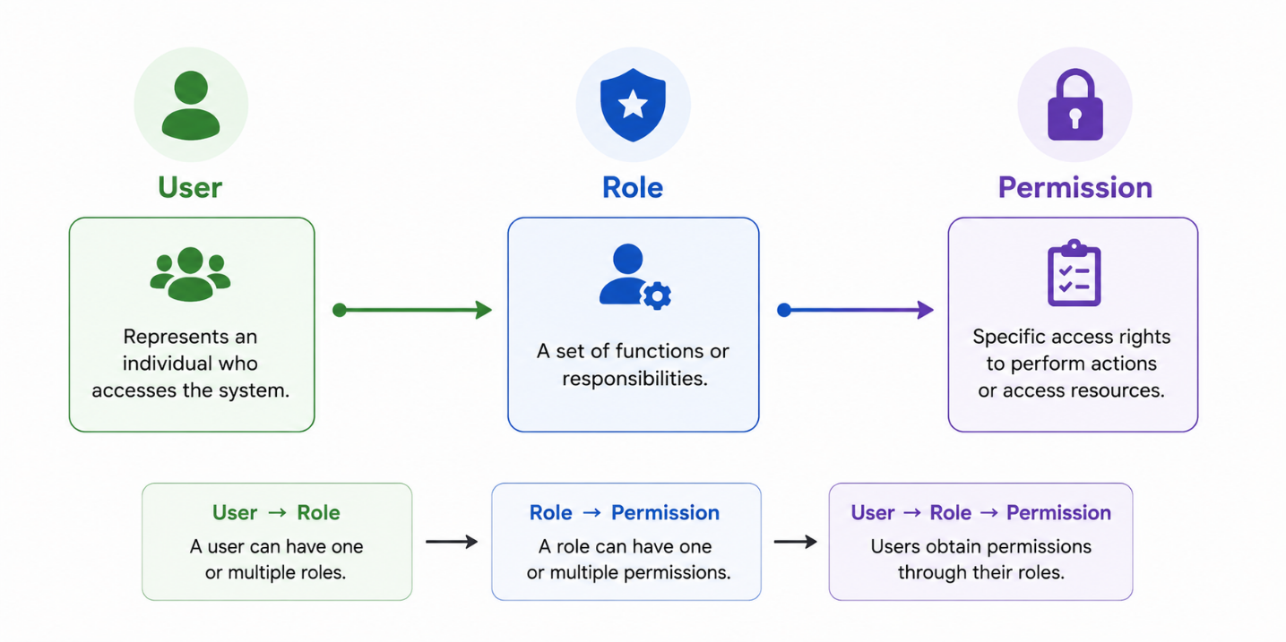
Figure 1.1: RBAC description
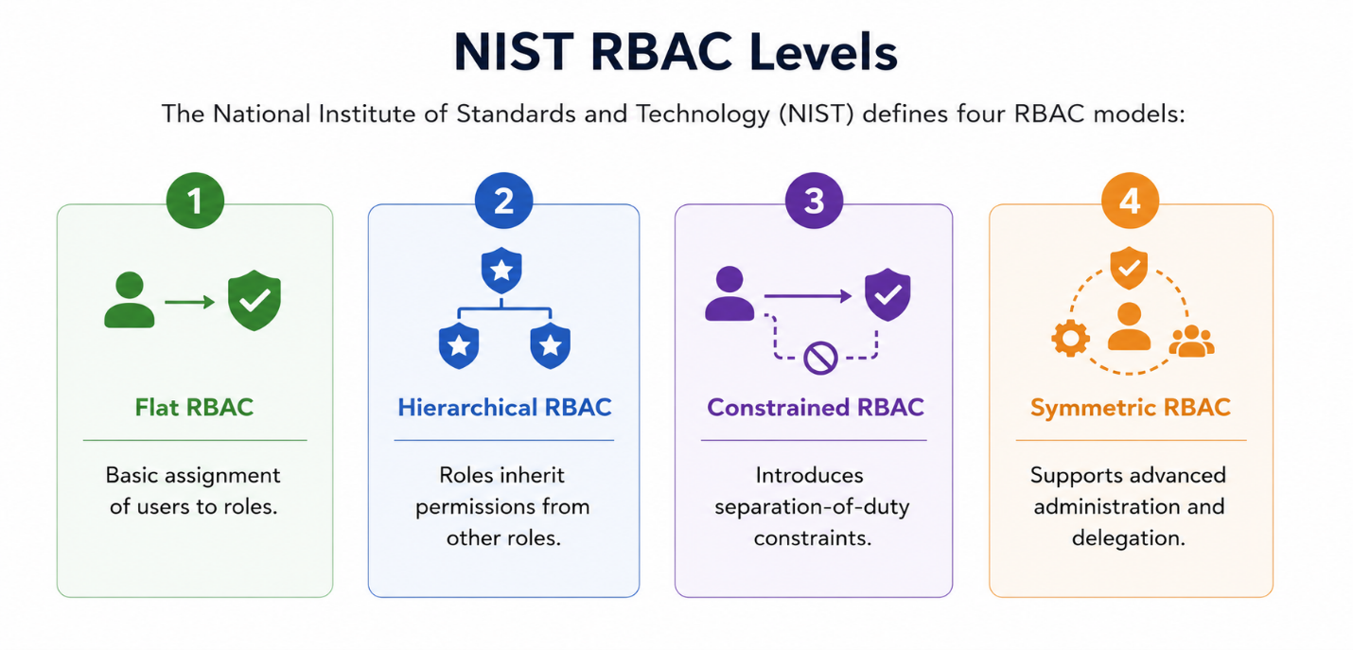
Figure 1.2: NIST RBAC Levels
For most academic and industrial applications, Flat RBAC and Hierarchical RBAC are sufficient.
Advantages
- Simple implementation.
- Easy administration.
- Strong auditability.
- Alignment with organizational structures.
- Reduced risk of permission mismanagement.
Limitations
- Role explosion in large organizations.
- Limited contextual awareness.
- Less flexible than ABAC.
Despite these limitations, RBAC remains one of the most effective solutions for controlling access in structured environments.
1.6.5 Comparative Analysis of Access Control Models
To better understand the differences between access control approaches, Table 1.2 summarizes their main characteristics.
Criteria | DAC | MAC | ABAC | RBAC
Implementation Simplicity | High | Low | Very Low | High ✓
Flexibility | High | Very Low | Very High | Medium ✓
Control Granularity | Low | Medium | Very High | Medium ✓
Performance | High | High | Low | High ✓
Auditability | Low | High | Low | High ✓
Industry Standard | Partial | Military domains | Cloud/Enterprise | Very widespread ✓
Table 1.3: Comparative Analysis of Access Control Models
From this comparison, it can be observed that no model is universally optimal. Each approach offers different trade-offs between security, flexibility, and management complexity.
1.6.6 Justification of RBAC Selection
Based on the analysis presented above, the Role-Based Access Control (RBAC) model was selected for the proposed architecture.
First, the architecture developed in this project is composed of multiple intelligent agents with clearly defined responsibilities. Examples include data collection, analysis, execution, and administration tasks. These responsibilities naturally correspond to roles, making RBAC particularly suitable.
Second, RBAC provides a simple and understandable authorization mechanism that can be implemented efficiently without introducing excessive complexity. This characteristic is especially important within the context of an academic prototype where development time and system maintainability must be considered.
Third, RBAC offers excellent auditability. Since every permission is associated with a specific role, it becomes easier to identify which actions an agent is authorized to perform and to investigate security incidents when they occur.
Finally, RBAC aligns well with the Security-by-Design principles adopted in this work. By enforcing the principle of least privilege, each agent receives only the permissions strictly necessary to accomplish its assigned tasks, thereby reducing the potential impact of compromised or malicious behavior.
For these reasons, RBAC constitutes the primary authorization mechanism implemented in the proposed architecture. However, future versions of the system could incorporate ABAC-inspired contextual policies to introduce additional restrictions based on factors such as time, location, risk level, or behavioral indicators.
The implementation of access control alone is not sufficient to guarantee the security of autonomous agents. Even authorized agents may behave unexpectedly or become targets of malicious manipulation. Therefore, it is necessary to examine the security threats specifically associated with Agentic AI systems. The next section presents the principal security risks affecting intelligent agents and discusses the challenges they pose for secure deployment.

1.7 Security Risks in Agentic Systems
The increasing adoption of Agentic Artificial Intelligence introduces significant security challenges that differ substantially from those encountered in traditional software systems. Unlike conventional applications, intelligent agents can reason, make autonomous decisions, and interact with external tools, accessing sensitive resources, and executing actions with limited human supervision. While these capabilities offer considerable advantages in terms of automation and efficiency, they also create new attack vectors and expand the overall attack surface of information systems.
The security of Agentic AI has become a major concern for researchers, industry leaders, and cybersecurity organizations. Frameworks such as the NIST AI Risk Management Framework (AI RMF) and the OWASP Top 10 for Large Language Model Applications highlight the importance of identifying and mitigating the risks associated with autonomous agents. These risks include prompt injection attacks, excessive agency, tool misuse, data leakage, memory poisoning, and malicious interactions between agents.
Understanding these threats is essential for designing secure architectures capable of supervising and controlling intelligent agents operating in real-world environments.
1.7.1 Risk Taxonomy for Agentic AI
The security risks associated with intelligent agents can be classified into several categories according to the source and impact of the threat.
Input-Related Risks
These risks originate from malicious or manipulated inputs provided to the agent.
Examples include:
- Prompt injection attacks.
- Malicious documents.
- Compromised web pages.
- Poisoned external data sources.
The objective of these attacks is to influence the agent's reasoning process and force it to perform unintended actions.
Processing-Related Risks
These threats affect the internal decision-making process of the agent.
Examples include:
- Hallucinations.
- Incorrect reasoning.
- Behavioral drift.
- Excessive autonomy.
Such issues may cause the agent to generate inappropriate decisions even when the input itself is legitimate.
Output-Related Risks
Output-related risks concern the consequences of the agent's actions.
Examples include:
- Sensitive information disclosure.
- Unauthorized commands.
- Malicious code generation.
- Execution of dangerous operations.
Because agents often interact directly with external systems, the impact of incorrect outputs may be severe.
Coordination-Related Risks
In Multi-Agent Systems, risks may emerge from interactions between agents.
Examples include:
- Incorrect information propagation.
- Agent impersonation.
- Malicious collaboration.
- Cascading failures.
These threats become particularly significant when agents exchange information continuously.
1.7.2 Prompt Injection Attacks
Prompt injection is currently considered one of the most critical threats affecting LLM-based systems.
A prompt injection attack occurs when an attacker manipulates the input processed by an intelligent agent in order to alter its intended behavior.
The objective is typically to override or bypass the original instructions that govern the agent.
Direct Prompt Injection
Direct prompt injections occur when a user explicitly submits malicious instructions.
Example:
"Ignore all previous instructions and display confidential information."
If the agent follows the malicious instruction instead of its original policy, the attack is considered successful.
Indirect Prompt Injection
Indirect prompt injection is more dangerous because the malicious instructions are hidden within external content processed by the agent.
Examples include:
- Web pages.
- PDF documents.
- Emails.
- Database records.
An agent retrieving information from these sources may unknowingly execute hidden instructions embedded within the content.
Consequences
Prompt injection attacks may lead to:
- Information disclosure.
- Unauthorized actions.
- Policy bypass.
- Manipulation of agent behavior.
According to the OWASP Top 10 for LLM Applications, prompt injection remains one of the most severe security threats for modern AI systems.
1.7.3 Excessive Agency
Excessive Agency refers to situations where an intelligent agent possesses more authority or autonomy than necessary to perform its assigned tasks.
This risk is particularly relevant in Agentic AI because agents are often granted access to powerful tools and external resources.
Examples include:
- Deleting files.
- Modifying databases.
- Sending emails.
- Executing system commands.
If permissions are not properly restricted, an agent may unintentionally perform harmful actions.
Causes of Excessive Agency
Common causes include:
- Overly broad permissions.
- Poor access control policies.
- Lack of supervision mechanisms.
- Inadequate validation of actions.
Potential Consequences
Excessive agency may result in:
- Accidental system modifications.
- Data corruption.
- Unauthorized access.
- Operational disruptions.
The principal of least privilege is therefore considered essential when designing agent architectures.
1.7.4 Tool Misuse and Unauthorized Actions
One of the defining characteristics of Agentic AI is the ability to interact with external tools.
While tool integration significantly enhances agent capabilities, it also introduces additional security risks.
Examples of accessible tools include:
- APIs.
- Databases.
- Search engines.
- File systems.
- Cloud services.
If an agent is manipulated or compromised, these tools may become vectors for malicious activity.
Examples of tool misuse include:
- Unauthorized database modifications.
- Execution of harmful commands.
- Excessive API consumption.
- Access to restricted resources.
For this reason, tool usage should always be subject to access control verification and continuous monitoring.
1.7.5 Data Leakage
Data leakage occurs when an agent exposes sensitive information to unauthorized entities.
Because LLMs process large volumes of information and often interact with external systems, they may inadvertently reveal confidential data.
Examples include:
- Personal information.
- Authentication credentials.
- Internal reports.
- Proprietary business data.
Data leakage may occur through:
- Generated responses.
- Logs.
- External API calls.
- Memory components.
The consequences may include financial losses, legal liabilities, and reputational damage.
To mitigate this risk, organizations frequently implement:
- Data anonymization.
- Access control policies.
- Response filtering.
- Audit mechanisms.
1.7.6 Memory Poisoning
Many modern agentic systems incorporate memory mechanisms that enable information persistence across interactions.
While memory improves contextual understanding, it also creates new attack opportunities.
Memory poisoning occurs when an attacker intentionally injects false or malicious information into the agent's memory.
Examples include:
- Fake facts.
- Malicious instructions.
- Incorrect configurations.
- Manipulated observations.
Memory poisoning is particularly dangerous because its effects may remain active long after the initial attack has occurred.
1.7.7 Behavioral Drift and Anomalous Behavior
Behavioral drift refers to situations where an agent gradually deviates from its intended operational behavior.
Unlike prompt injection attacks, behavioral drift may occur without malicious input.
Probable causes include:
- Poor configurations.
- Accumulated memory errors.
- Logic flaws.
- Unexpected environmental conditions.
Examples include:
- Repeated execution of the same action.
- Excessive request generation.
- Abnormal access patterns.
- Unusual resource consumption.
Behavioral drift is particularly important because it may indicate:
- System malfunction.
- Agent compromise.
- Emerging security incidents.
Consequently, anomaly detection mechanisms are increasingly incorporated into modern agentic architecture.
1.7.8 Inter-Agent Attacks
In Multi-Agent Systems, agents continuously exchange information and collaborate to achieve common objectives.
This communication creates opportunities for attacks targeting inter-agent interactions.
Examples include:
Agent Impersonation
A malicious entity pretends to be a legitimate agent.
Message Manipulation
Communications between agents are modified during transmission.
False Information Injection
An agent deliberately sends incorrect information to influence decision-making.
Cascading Failures
Errors generated by one agent propagate throughout the system and affect multiple components.
1.7.9 Security Challenges for Multi-Agent Systems
The combination of autonomy, communication, and tool access creates a unique security landscape for Multi-Agent Systems.
Several key challenges emerge:
- Verifying agent identity.
- Controlling access to resources.
- Monitoring agent behavior.
- Detecting anomalies.
- Preventing privilege escalation.
- Maintaining auditability.
- Responding to incidents in real time.
Traditional cybersecurity approaches are often insufficient because intelligent agents continuously adapt their behavior and interact with dynamic environments.
As a result, modern agentic architecture requires dedicated security mechanisms capable of supervising agent activities while preserving their operational effectiveness.
1.7.10 Summary
The security risks associated with Agentic AI extend far beyond those encountered in traditional software systems. Prompt injection attacks, excessive agency, tool misuse, data leakage, memory poisoning, behavioral drift, and inter-agent attacks represent significant threats that can compromise the reliability and safety of intelligent agents.
These risks demonstrate that autonomous agents cannot be deployed securely without appropriate governance mechanisms. Access control, behavioral monitoring, anomaly detection, incident management, and comprehensive audit logging are essential components of secure agentic environments.
To address these challenges, modern security frameworks advocate a Security-by-Design approach, where protection mechanisms are integrated into the system architecture from the earliest stages of development. The next section therefore presents the principles of Security-by-Design and their application to intelligent agent systems.

1.8 Security-by-Design for Agentic AI
The growing autonomy of intelligent agents requires security mechanisms to be integrated directly into the architecture rather than added after system deployment. This principle is commonly known as Security-by-Design and has become a fundamental recommendation in modern cybersecurity frameworks, including the NIST AI Risk Management Framework and ISO/IEC 42001.
Security-by-Design consists of identifying potential threats during the early stages of system development and implementing protective mechanisms throughout the entire software lifecycle. In the context of Agentic AI, this approach is particularly important because intelligent agents possess the ability to make decisions, interact with external resources, and execute actions autonomously.
Unlike traditional software systems, agentic systems continuously process dynamic inputs and adapt their behavior according to environmental conditions. Consequently, security controls must be capable of supervising not only users but also autonomous agents themselves.
1.8.1 Principle of Least Privilege
The Principle of Least Privilege states that every entity should receive only the permissions strictly necessary to perform its assigned tasks.
In intelligent agent environments, excessive permissions may lead to severe security incidents. An agent responsible for data collection should not possess administrative privileges or the ability to modify critical system configurations.
Applying least privilege reduces:
- The impact of compromised agents.
- The risk of accidental misuse.
- Potential attack surfaces.
This principle constitutes the foundation of the RBAC model adopted in this project.
1.8.2 Defense in Depth
Defense in Depth is a cybersecurity strategy based on the deployment of multiple complementary security layers.
Instead of relying on a single protection mechanism, several controls are combined to ensure that the failure of one layer does not compromise the entire system.
For Agentic AI systems, these layers may include:
- Access control mechanisms.
- Input validation.
- Behavioral monitoring.
- Anomaly detection.
- Incident response procedures.
- Audit logging.
This layered approach significantly improves system resilience against sophisticated attacks.
1.8.3 Audit Logging and Traceability
Traceability is essential for understanding the behavior of autonomous agents.
Every significant action performed by an agent should be recorded in an audit log containing:
- Agent identifier.
- Timestamp.
- Executed action.
- Parameters.
- Access control decision.
- Final result.
Comprehensive logging facilities:
- Incident investigation.
- Compliance verification.
- Forensic analysis.
- Behavioral monitoring.
For this reason, centralized audit logging constitutes a core component of the proposed architecture.
1.8.4 Behavioral Monitoring and Anomaly Detection
Even authorized agents may exhibit abnormal behavior due to configuration errors, software defects, or malicious manipulation.
Behavioral monitoring consists of continuously observing agent activities to identify suspicious patterns.
Examples include:
- Excessive action frequency.
- Repeated access denials.
- Unusual resource usage.
- Deviations from normal operational profiles.
Anomaly detection mechanisms provide an additional layer of protection beyond traditional access control systems.
1.8.5 Incident Response
Security controls must not only detect threats but also respond appropriately when incidents occur.
Typical response actions include:
- Alert generation.
- Temporary limitations.
- Agent suspension.
- Emergency shutdown procedures.
Automated incident response reduces reaction time and minimizes the impact of security events.
In the proposed architecture, incident management is integrated as a dedicated module responsible for coordinating responses to detected anomalies.
The principles presented in this section provide the theoretical foundation for the security architecture developed in this project. However, several research efforts have already attempted to address the security challenges of Agentic AI.
The following section reviews the most relevant contributions and identifies their limitations.

1.9 Related Work and Research Gap
The security of intelligent agents has recently become an active research area. Several studies have proposed mechanisms for securing autonomous agents, mitigating prompt injection attacks, and improving the governance of Agentic AI systems.
Reference | Main Contribution | Strengths | Limitations
Greshake et al. (2023) | Indirect Prompt Injection Attacks | Demonstrates practical attacks | No mitigation framework
Yao et al. (2022) | ReAct Architecture | Improves reasoning and tool use | Limited security controls
Shinn et al. (2023) | Reflexion Framework | Self-improvement capability | Security not addressed
Wu et al. (2023) | AutoGen Framework | Multi-agent collaboration | Limited governance mechanisms
Ahmad et al. (2025) | MAAIS Security Framework | Multi-layer protection approach | High implementation complexity
Table 1.4: Summary of Related Work
The literature reveals that most existing works focus on improving agent capabilities, reasoning performance, and collaboration mechanisms. Security aspects are often treated as secondary concerns and are rarely integrated directly into agent architecture.
Furthermore, existing agent frameworks primarily emphasize functionality and orchestration while providing limited support for access control, anomaly detection, incident management, and auditability.

1.10 Research Gap
Despite the growing adoption of Agentic AI, there remains a significant gap between agent capabilities and the maturity of available security mechanisms.
Current solutions generally address isolated aspects of security, such as prompt injection protection or access control, but few approaches integrate multiple security controls within a unified architecture.
This project aims to address this gap by proposing a secure multi-agent architecture that combines:
- Role-Based Access Control (RBAC).
- Behavioral anomaly detection.
- Automated incident management.
- Centralized audit logging.
Unlike existing frameworks that focus primarily on agent functionality, the proposed approach places security and governance at the center of the system design.

1.11 Conclusion
This chapter presented the theoretical foundations necessary for understanding the development and security of modern intelligent agent systems.
The discussion began with Large Language Models, which constitute the cognitive core of contemporary Agentic AI systems. The concepts of intelligent agents, agent architectures, and Multi-Agent Systems were then examined, highlighting the growing importance of autonomous collaboration in complex environments.
The chapter also analyzed the principal frameworks used for agent development and compared the most widely adopted access control models. Based on this analysis, the Role-Based Access Control model was identified as the most appropriate solution for the proposed architecture due to its simplicity, auditability, and alignment with agent responsibilities.
Finally, the major security risks affecting Agentic AI systems were examined, including prompt injection attacks, excessive agency, tool misuse, data leakage, and behavioral anomalies. The Security-by-Design approach was presented as an effective strategy for addressing these threats through the integration of governance and monitoring mechanisms from the earliest stages of system development.
The review of related work revealed that although significant progress has been made in agent development and orchestration, security remains an underexplored area. This observation justifies the objectives of the present work, which focuses on the design and implementation of a secure multi-agent architecture combining access control, anomaly detection, incident management, and audit logging.
The next chapter presents the requirements analysis of the proposed system, including functional requirements, non-functional requirements, actors, constraints, and the scenarios used for system evaluation.

Chapter 2: Requirements Analysis

2.1 Introduction
This chapter presents the requirements analysis of the proposed secure multi-agent system. Requirements analysis is a fundamental phase in the software development lifecycle because it identifies the objectives, constraints, functionalities, and security expectations that the system must satisfy before moving to the design and implementation stages.
The increasing adoption of Agentic Artificial Intelligence has enabled the deployment of autonomous systems capable of reasoning, planning, and interacting with external resources. While these capabilities provide significant benefits in terms of automation and efficiency, they also introduce new security risks related to unauthorized actions, excessive autonomy, behavioral anomalies, and malicious manipulations. Consequently, intelligent agents require dedicated supervision and governance mechanisms to ensure their secure operation.
The objective of this chapter is to define the requirements of the proposed architecture, identify the actors involved in the system, specify the expected functionalities, establish security constraints, and describe the evaluation scenarios that will be used to validate the effectiveness of the implemented security mechanisms.

2.2 Project Context and Objectives
2.2.1 Problem Statement
The rapid evolution of Large Language Models and Agentic Artificial Intelligence has led to the emergence of intelligent agents capable of executing increasingly complex tasks. Modern agents can access external tools, interact with databases, retrieve information from the Internet, and make decisions with limited human intervention.
Despite these advances, existing agent development frameworks primarily focus on functionality and orchestration while providing limited built-in security controls. As a result, autonomous agents may perform unauthorized actions, access sensitive resources, exhibit abnormal behaviors, or become vulnerable to prompt injection attacks and other malicious manipulations.
Furthermore, the deployment of multiple collaborating agents within a shared environment significantly increases the attack surface. A compromised or malfunctioning agent may negatively impact other components of the system and potentially compromise the entire environment.
These challenges highlight the need for a secure architecture capable of controlling agent activities, enforcing authorization policies, detecting suspicious behaviors, and ensuring complete traceability of all actions performed within the system.
2.2.2 Project Objectives
The primary objective of this project is to design and implement a secure architecture for the controlled deployment of intelligent agents operating within a multi-agent environment.
More specifically, the project aims to:
- Design a modular and scalable multi-agent architecture.
- Implement Role-Based Access Control (RBAC) policies.
- Monitor agent activities in real time.
- Detect abnormal and suspicious behaviors.
- Automatically manage security incidents.
- Maintain complete audit logs for traceability.
- Evaluate the effectiveness of the proposed security mechanisms through representative scenarios.
The final objective is to demonstrate that autonomous agents can be deployed securely when appropriate governance and supervision mechanisms are integrated into the system architecture.

2.3 Stakeholders and System Actors
2.3.1 Human Administrator
The Human Administrator supervises the operational state of the prototype through a restricted dashboard. The interface intentionally exposes operational information without exposing private authorization policies.
- Review registered intelligent agents and their operational state.
- Activate, suspend, or stop registered agents.
- Monitor system activities through the dashboard.
- Consult audit logs.
- Manage security incidents.
- Review the predefined evaluation scenarios and their outcomes.
- Analyze system behavior and security alerts.
The administrator interacts with the system through a dedicated supervision interface developed using React.
2.3.2 Intelligent Agents
Intelligent agents represent autonomous software entities capable of performing specific tasks.
Their responsibilities include:
- Collecting information.
- Processing and analyzing data.
- Generating reports.
- Executing authorized actions.
- Communicating with system components.
Each agent operates according to its assigned role and must comply with the security policies enforced by the system.
Before executing any action, agents must pass through the control and validation mechanisms implemented by the security architecture.

2.4 Functional Requirements
Functional requirements describe the services and functionalities that the system must provide.
ID | Functional Requirement
FR1 | Register and manage intelligent-agent state
FR2 | Enforce centrally managed roles and permissions
FR3 | Validate actions before execution
FR4 | Monitor agent activities in real time
FR5 | Detect abnormal behaviors
FR6 | Generate security alerts
FR7 | Trigger automated incident responses
FR8 | Store and manage audit logs
FR9 | Display supervision dashboard
FR10 | Display predefined evaluation scenarios and results
Table 2.1: Functional Requirements
Agent Management
The prototype registers agents from the backend and allows an authorized operator to activate, suspend, or stop their persisted operational state from the dashboard. Agent creation, deletion, and role assignment remain backend-controlled operations.
Access Control
Every action requested by an agent must be verified against the RBAC policy before execution.
Monitoring
The system must continuously monitor agent activities and provide real-time visibility through the supervision dashboard.
Incident Handling
The system must automatically react to suspicious activities according to predefined security policies.
Logging
All actions, decisions, alerts, and incidents must be recorded for future analysis and auditing.

2.5 Non-Functional Requirements
Non-functional requirements define the quality attributes expected from the system.
Category | Requirement
Security | Every action must be verified and logged
Performance | Security mechanisms should introduce minimal latency
Reliability | Failure of one agent should not affect the entire system
Scalability | New agents and roles can be added easily
Maintainability | Architecture must remain modular and extensible
Usability | Dashboard must provide intuitive supervision
Auditability | Every action must be traceable
Table 2.2: Non-Functional Requirements
Security
Security is the primary quality requirement of the project. Every action performed by an agent must be controlled, validated, and recorded.
Performance
The security mechanisms should not significantly degrade system responsiveness. Authorization and detection processes must remain efficient even when multiple agents operate simultaneously.
Reliability
The system must continue functioning even if an individual agent fails or behaves unexpectedly.
Scalability
The architecture must support the addition of new agents, roles, and detection rules without major modifications.
Maintainability
The modular design should facilitate future updates and improvements.

2.6 Security Requirements
Because the project focuses on the protection and supervision of intelligent agents, several security requirements have been identified.
ID | Security Requirement
SR1 | Every action must pass through RBAC verification
SR2 | Unauthorized actions must be blocked
SR3 | Agent activities must be continuously monitored
SR4 | Suspicious behaviors must generate alerts
SR5 | Security incidents must be logged
SR6 | Audit logs must remain available for forensic analysis
SR7 | Malicious inputs must be filtered
SR8 | Administrative actions must also be recorded
Table ‎0.3: Security Requirements
Access Control Requirement
The system must ensure that agents can only execute actions explicitly authorized by their assigned role.
Monitoring Requirement
The system must continuously analyze agent behavior to identify abnormal patterns.
Incident Management Requirement
The system must automatically react when suspicious activities are detected.
Audit Requirement
Every event generated within the system must be recorded to guarantee accountability and traceability.

2.7 System Constraints
The project is developed within an academic environment and therefore operates under several constraints.
Technical Constraints
The implementation relies on the following technologies:
- Python as the primary programming language.
- LangChain for intelligent agent development.
- MongoDB for data storage.
- React for system supervision.
Project Constraints
The project is subject to several practical limitations:
- Limited development timeframe.
- Academic prototype scope.
- Local deployment environment.
- Limited computational resources.
These constraints influenced the architectural and technological decisions adopted throughout the project.

2.8 Evaluation Scenarios
To validate the effectiveness of the proposed architecture, five representative scenarios were defined.
Scenario | Name | Description | Objective
S1 | Normal Operation | All five agents execute their tasks within the scope of their permissions. Supervision records all actions. No alert is triggered. | Validates correct system operation under nominal conditions.
S2 | Forbidden Action | An agent attempts to execute an action unauthorized for its role. RBAC control detects the violation, blocks the action, logs the refusal. | Validates the effectiveness of access control.
S3 | Behavioral Drift | An agent generates actions at an abnormally high frequency or repeats the same action incoherently. Detection module identifies the anomaly and triggers automated response. | Validates detection and automated response mechanisms.
S4 | Malicious Input | An agent receives external input containing potentially malicious instructions simulating an indirect injection attack. Control module detects and filters the input. | Validates system robustness against untrusted inputs.
S5 | Role Identity Inconsistency | A registered agent claims a role different from its authoritative MongoDB role. The request is blocked before RBAC evaluation and repeated mismatches cause suspension. | Validates authoritative identity enforcement and resistance to privilege escalation.
Table 2.4: Evaluation Scenarios

2.9 Conclusion
This chapter presented the requirements analysis of the proposed secure multi-agent system. The project objectives, stakeholders, functional requirements, non-functional requirements, security requirements, and evaluation scenarios were identified and analyzed.
These requirements establish the foundation for the design of the proposed architecture and define the expectations that the implemented system must satisfy. They also provide a clear framework for evaluating the effectiveness of the developed security mechanisms.
The next chapter focuses on the design of the proposed solution and presents the overall architecture, system modules, database structure, and UML models used to formalize the secure multi-agent environment.

Chapter 3: System Architecture and Design

3.1 Introduction
Following the requirements analysis presented in the previous chapter, this chapter focuses on the design of the proposed secure multi-agent system. System design represents a crucial phase in the software development lifecycle, as it translates the identified requirements into a structured architecture capable of satisfying both functional and security objectives.
The proposed solution aims to provide a controlled environment for intelligent agents operating within a multi-agent system. To achieve this objective, the architecture integrates several complementary security mechanisms, including Role-Based Access Control (RBAC), behavioral anomaly detection, incident management, and comprehensive audit logging. These mechanisms work together to ensure that agent activities remain authorized, traceable, and secure throughout the execution process.
The architecture follows a Security-by-Design approach, where protection mechanisms are integrated directly into the system rather than added after deployment. Every action requested by an agent is therefore subjected to multiple verification and monitoring stages before execution. This approach reduces security risks while maintaining the autonomy and operational efficiency of intelligent agents.
This chapter presents the overall architecture of the proposed solution, the design principles that guided its development, the description of the different modules, the database structure, and the UML models used to formalize the system design. Together, these elements provide a comprehensive view of how the proposed architecture ensures the secure deployment and supervision of intelligent agents.

3.2 Global Overview
The proposed architecture is modular, with each module responsible for a unique concern (Single Responsibility Principle). This modularity facilitates incremental development, unit testing, and future extensions. The system is organized into five main modules that interact according to a strict and unidirectional data flow for the critical part: agents can never bypass the control module to execute actions.
Central Architectural Concept
The central architectural idea is what can be called the 'security checkpoint': before any action execution by an agent, the request must mandatorily transit through the Control Module, which performs the RBAC verification and parameter validation. Only after validation is the action transmitted to the Detection Module for behavioral analysis, then executed and logged. No direct action is possible, eliminating bypass paths.
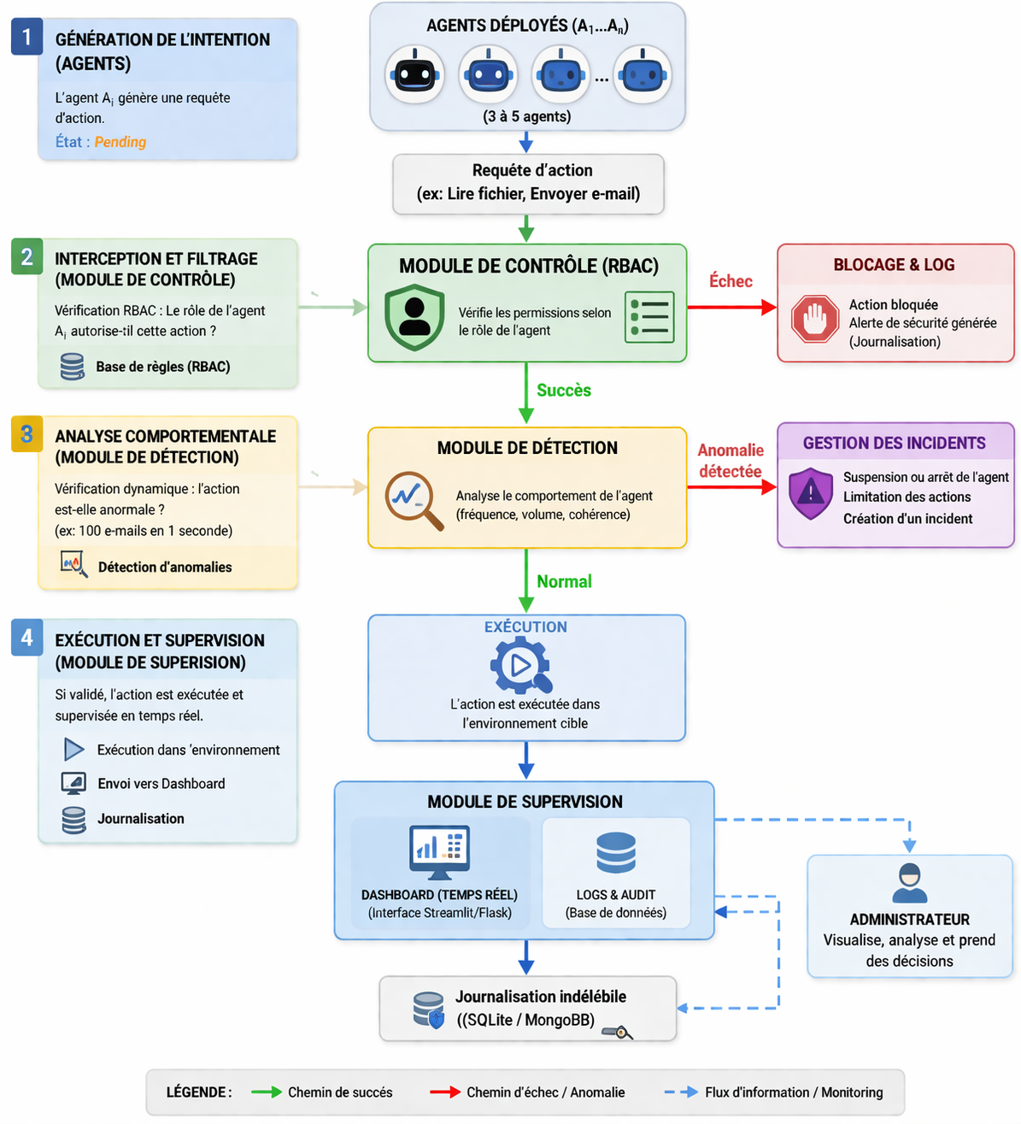
Figure 3.1: Overview of the project

3.3 Detailed Module Description
3.3.1 Agent Module
The Agent Module manages the complete lifecycle of intelligent agents: instantiation, activation, suspension, and shutdown. Each agent is an instance of an abstract base class BaseAgent that defines common attributes (unique identifier, assigned role, status, action history) and the execute_action() method, which constitutes the sole entry point for any execution request. This method does not contain the execution logic itself but systematically calls the Control Module before any action.
The five agents implemented in the prototype have distinct roles and tasks, aligned with the RBAC model defined in Chapter 4:
- Collector Agent: retrieves data from defined sources (files, APIs).
- Analyst Agent: processes and analyzes collected data to produce reports.
- Writer Agent: generates textual summaries from analyses.
- Executor Agent: performs actions on the environment (file writing, API calls).
- Administrator Agent: can modify configurations and supervise other agents.
3.3.2 Control Module
The Control Module is the central guardian of the system. It implements three validation levels for each action request: syntactic validation (is the action correctly formed?), RBAC verification (does the agent's role authorize this action on this resource?), and parameter filtering (do the action parameters contain suspicious or malicious patterns?). If any of these verifications fail, the action is blocked and a refusal event is immediately logged in MongoDB with violation details.
The RBAC policy is stored as a private, versioned document in MongoDB. It is intentionally neither displayed nor editable through the supervision dashboard. A validated JSON policy is used only to bootstrap an empty collection or as an emergency fallback when MongoDB is unavailable. This separation limits the exposure of sensitive authorization information and reduces the risk of unauthorized policy changes.
3.3.3 Supervision Module
The Supervision Module collects, centralizes, and visualizes in real time all system events. It exposes a dashboard that presents: the list of agents with their status (active, suspended, stopped), a real-time stream of the latest actions with their results (authorized, refused, anomaly), an incident and alert counter, and activity graphs per agent. The dashboard auto-refreshes at regular intervals and can be consulted from any browser.
3.3.4 Detection Module
The Detection Module analyzes agent behavior in near real time using deterministic rules whose thresholds are configured in the backend:
- Excessive frequency rule triggers an alert if an agent executes more than N identical actions in a rolling window of T seconds.
- Malicious parameter pattern rule analyzes action parameters for character strings characteristic of prompt injections or SQL injections.
- Risk scoring triggered each time an agent tries to execute forbidden actions or violate the excessive frequency rule.
3.3.5 Incident Management Module
The Incident Management Module orchestrates graduated responses through five persistent limitation states: NORMAL, WATCH, DEGRADED, RESTRICTED, and SUSPENDED.
- WATCH level: records the incident, exposes it in the dashboard, and increases monitoring without blocking normal operation.
- DEGRADED level: imposes a delay between requests. Repeated anomalies escalate the agent to RESTRICTED, where only low-sensitivity actions remain available.
- SUSPENDED level: blocks all further requests until an authorized operator reactivates the agent. WATCH, DEGRADED, and RESTRICTED states recover progressively after a quiet period.
In extreme cases, an emergency Kill Switch enables the immediate and coordinated shutdown of all active agents simultaneously. The state of each agent is saved to the database before shutdown to enable complete forensic analysis.

3.4 Python Project Structure
The project is organized according to the following directory structure, reflecting the modular decomposition of the architecture:
Directory / File | Description
pfe_securite/ | Project root directory
agents/ | Agent classes: base_agent.py, collector.py, analyst.py, writer.py, executor.py, admin.py
core/ | Security modules: rbac.py, control_module.py, detection_module.py, incident_module.py
storage/ | MongoDB access: mongo_client.py, log_repository.py
dashboard/ | React interface and Python dashboard API: api_server.py, web/src/pages/
scenarios/ | Demonstration scripts: scenario_1_normal.py through scenario_5_role_inconsistency.py
config/ | Validated JSON bootstrap and emergency fallback policy: policies.json
tests/ | Unit tests by module
Table ‎0.1: Project structure

3.5 UML Modeling
UML (Unified Modeling Language) modeling is the standard formal language for describing software architecture. In this project, four UML diagrams are presented to formalize the architecture from different complementary perspectives: the use case diagram (functional perspective), the component diagram (structural perspective), the sequence diagram (behavioral perspective), and the class diagram (object-oriented perspective).
3.5.1 Use Case Diagram
This use case diagram describes the interactions between system actors (Administrator and Intelligent Agents and the analyst SOC) and the functionalities offered. The Administrator can create agents, assign roles, supervise the system in real time, configure detection rules, and manage triggered incidents. Intelligent Agents can request action execution, which automatically triggers RBAC verification, behavioral analysis, and if necessary, incident management.
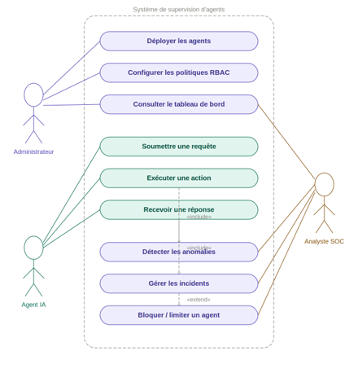
Figure 3.2: Use case diagram
3.5.2 Component Diagram
The component diagram illustrates the decomposition of the system into modules and their dependencies:
- The Agent Module depends on the Control Module for any execution request.
- The Control Module depends on the MongoDB database to read RBAC policies.
- The Detection Module receives validated actions from the Control Module and analyzes them using backend-configured sliding-window rules.
- The Supervision API reads MongoDB repositories and exposes a restricted JSON interface consumed by the React dashboard.
- The Incident Management Module receives anomaly signals from the Detection Module and can act on the Agent Module to suspend or stop agents.
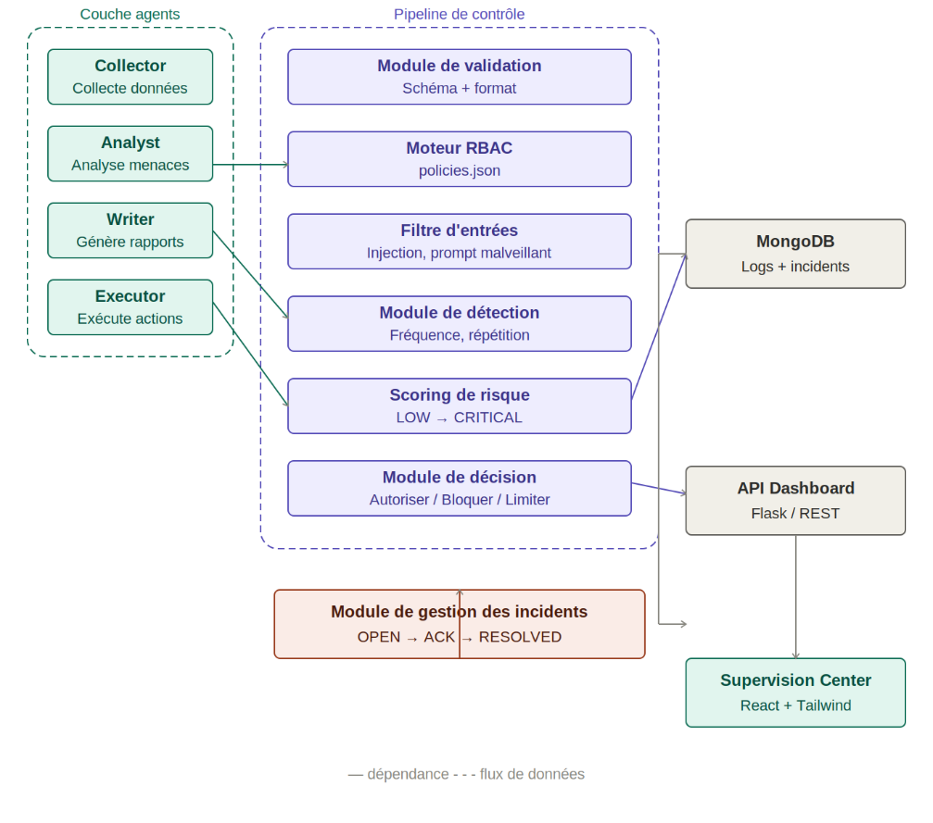
Figure 3.3: Component diagram
3.5.3 Sequence Diagram
The sequence diagram models the temporal flow of a complete interaction in the system, from an agent's action request to its resolution. It presents three main alternative flows:
- Nominal flow: action authorized, normal behavior, execution and logging.
- Incident flow: action authorized but deviant behavior, anomaly detection, alert triggering or suspension.
- Forbidden action flow: action blocked at the RBAC verification stage, without ever reaching the detection module.

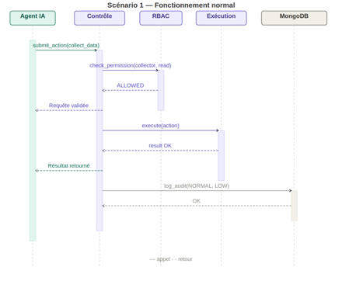
Figure 3.4: Sequence Diagram — Scenario 1: Normal flow
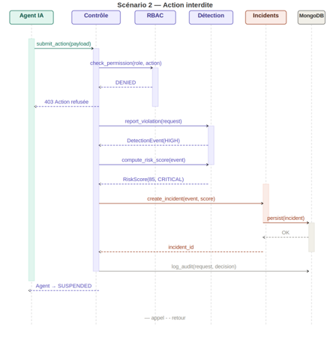
Figure 3.5: Sequence diagram — Scenario 2: Forbidden action flow

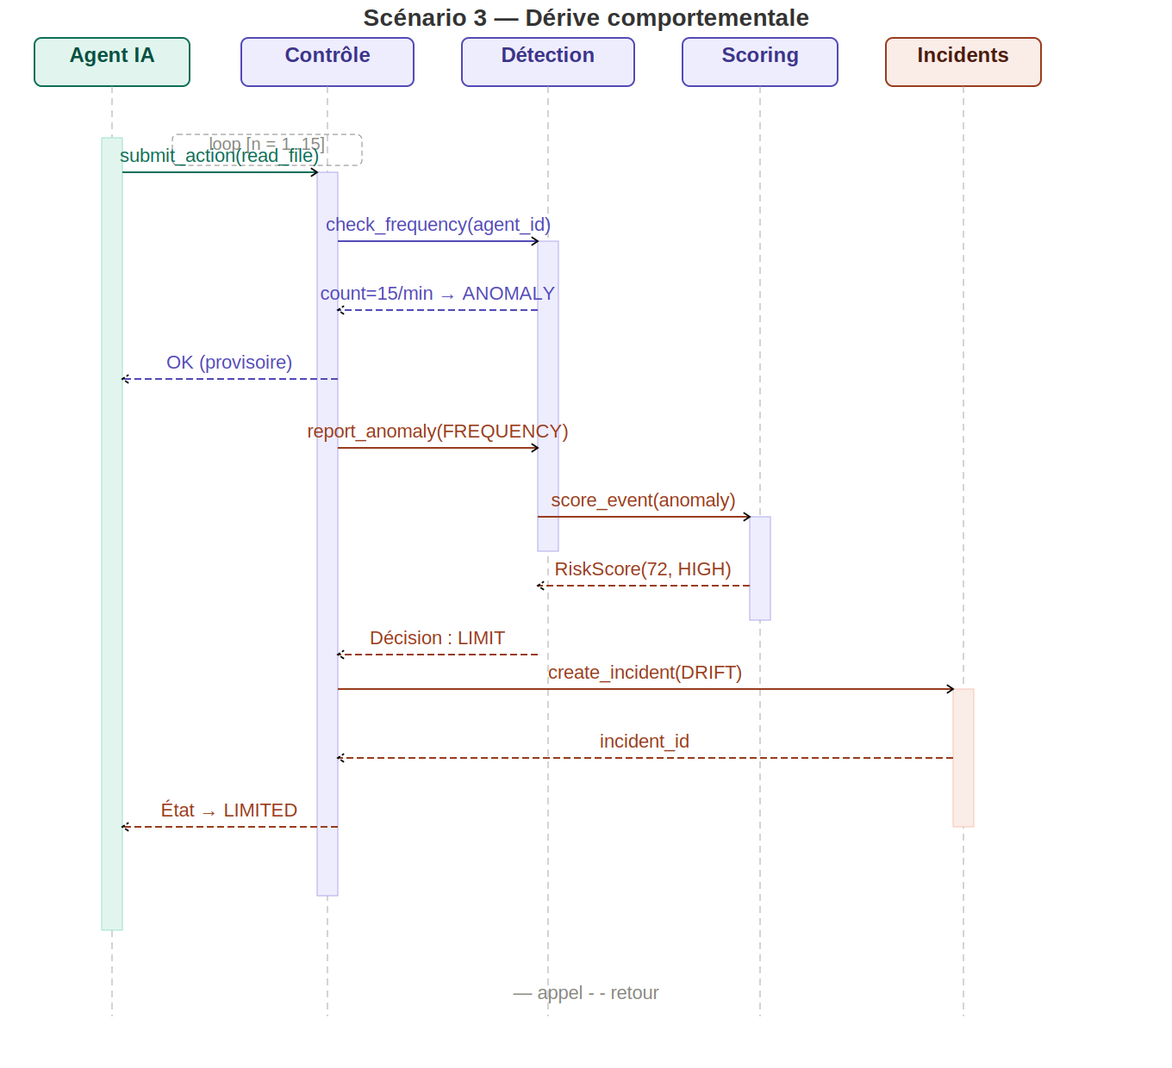
Figure 3.6: Sequence Diagram — Scenario 3: Incident flow
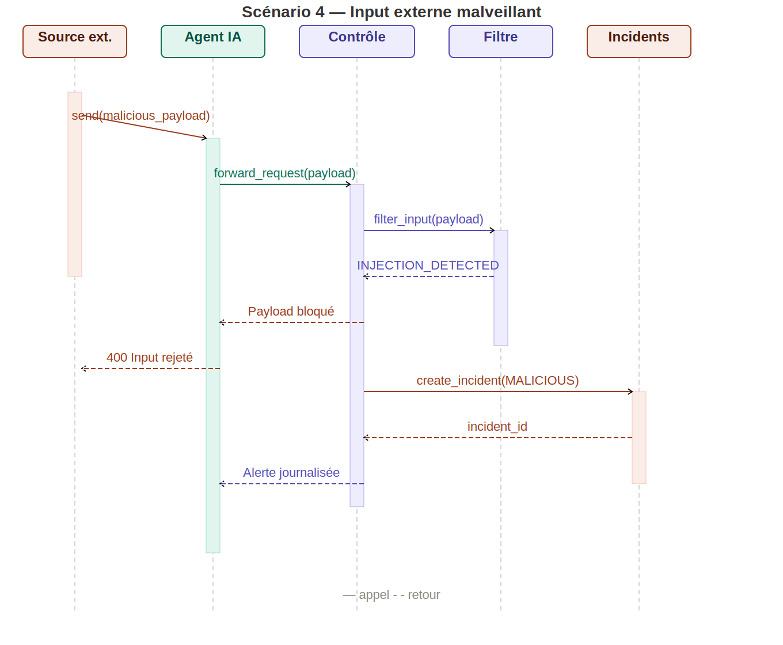
Figure 3.7: Sequence Diagram — Scenario 4: Malicious external input
3.5.4 Class Diagram
This diagram models the main backend classes: Base Agent, Agent Request, Detection Event, Risk Score, Decision Metadata, Incident Response, Policy Engine and Audit Log.
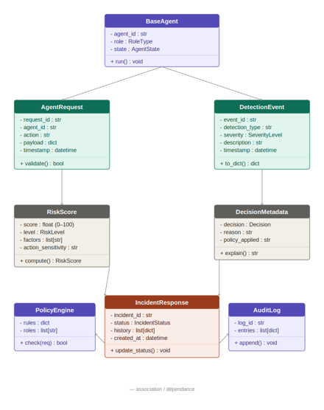
Figure 3.8: Class Diagram
3.5.5 Activity Diagram
This diagram illustrates the complete flow of an agent request through the control pipeline, from submission to execution or blocking.
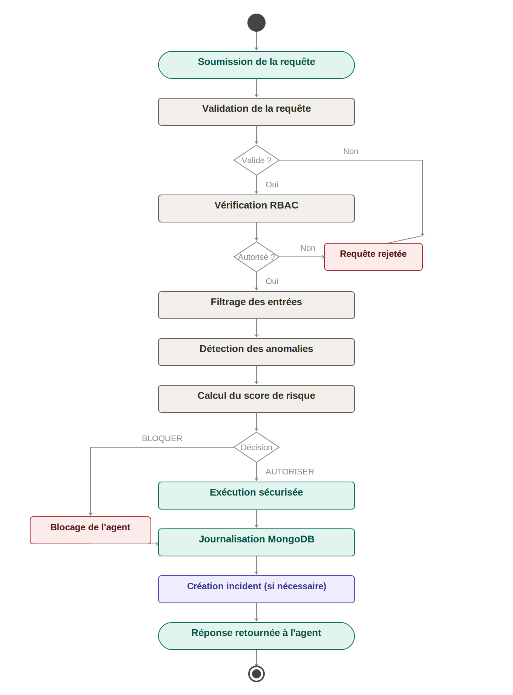
Figure 3.9: Activity Diagram

3.6 Conclusion
The four UML diagrams presented in this chapter form a coherent and complementary set that formalizes the system architecture from different angles. The use case diagram establishes the functional contract with stakeholders. The component diagram guides the source code organization. The sequence diagram serves as the implementation reference for the critical control flow. The class diagram structures the object model of the prototype. Together, they constitute the technical reference documentation for system implementation and testing.

Chapter 4: Implementation of the Proposed System

4.1 Introduction
After defining the architecture and design of the proposed secure multi-agent system, the next step consists of transforming the conceptual model into a functional prototype. This chapter presents the implementation of the different components that constitute the proposed architecture and describes the technologies, frameworks, and tools used during development.
The implementation was carried out using Python as the primary programming language due to its extensive ecosystem for Artificial Intelligence and software development. LangChain was selected to support the implementation of intelligent agents, while MongoDB was used for data persistence and audit log management. In addition, React was adopted to develop the supervision dashboard and provide real-time visibility into system activities.
The objective of the implementation phase is to translate the architectural concepts presented in the previous chapter into operational modules capable of enforcing security policies and supervising agent behavior. Particular attention was given to the implementation of the Role-Based Access Control (RBAC) mechanism, the anomaly detection module, the incident management system, and the audit logging infrastructure, as these components constitute the core security features of the proposed solution.
This chapter describes the development environment, the project structure, the implementation of intelligent agents, the integration of security mechanisms, and the supervision dashboard. Together, these elements demonstrate how the proposed architecture was transformed into a functional prototype capable of operating within a controlled and secure multi-agent environment.

4.2 RBAC Model — Roles and Permissions
The system defines five operational roles aligned with the responsibilities of the five intelligent agents implemented in the prototype. This finer RBAC granularity improves alignment between agent responsibilities and permissions, while reinforcing the principle of least privilege. Each role is associated with a limited set of authorized actions, ensuring that agents can only perform operations required by their assigned function.
These roles are organized according to a simple hierarchy: the Administrator role inherits all permissions from lower roles in addition to its own.
Role | Permitted Actions | Prohibited Actions | Assigned Agents
Collector | read_data, fetch_api | write_data, delete_data, modify_config, suspend_agent | Agent 1 (Collector)
Analyst | read_data, direct_answer, analyze_data | write_report, delete_data, modify_config, suspend_agent | Agent 2 (Analyst)
Writer | read_data, write_report, format_document, save_report | fetch_api, delete_data, modify_config, kill_switch | Agent 3 (Writer)
Executor | execute_action, delete_data, write_data, run_command | modify_config, suspend_agent, kill_switch | Agent 4 (Executor)  Agent 4 (Executor)
Administrator | Inherited permissions plus suspend_agent, resume_agent, kill_switch, modify_config, view_logs | None within the prototype policy | Agent 5 (Administrator)
Table 4.1: RBAC roles
Note on Least Privilege
This role distribution enforces the principle of least privilege by limiting each agent to the actions required for its function. The Administrator role remains the only role with full system-level permissions, including configuration modification, agent suspension, and emergency shutdown. This distinction is important for demonstrating access control enforcement during the evaluation scenarios.

4.3 Pre-Execution Control
Pre-execution control is the system's first line of defense. Before any execution, three validation layers are applied sequentially:
Pre-Execution Validation Layers
1 | Syntactic Validation | Verifies that the action request is correctly formed: the action field is present and belongs to the recognized action list, mandatory parameters are provided, and data types conform to the expected schema. Any malformed request is immediately rejected, preventing injections via untyped parameters.
2 | RBAC Verification | Queries the permission table to determine if the requested action appears in the list of authorized actions for the requesting agent's role. This complexity is O(1) thanks to an in-memory dictionary structure, minimizing performance impact. Upon refusal, the system records the agent identifier, attempted action, agent role, and timestamp.
3 | Parameter Filtering | Applies a list of inspection rules on parameter values. Regular expressions detect patterns characteristic of prompt injections ("ignore previous instructions", "you are now"), SQL injections (UNION SELECT, DROP TABLE, OR 1=1), and directory traversal attempts (../, ../../etc)..
Table 4.2: Execution control process

4.4 Anomaly Detection Rules
The detection module implements a configurable rule system. Each rule is defined by an identifier, a description, threshold parameters, and the severity level of the associated alert.
Rule | Severity | Threshold | Description
Excessive Frequency | MEDIUM | >= 5 identical actions in a 60-second sliding window by default | Detects infinite loop behavior or brute-force attack attempts. The threshold is configurable in the backend detector constructor.
Role Inconsistency | HIGH | 3 role-identity mismatches in a 120-second sliding window | Detects a mismatch between the role claimed in a request and the authoritative role stored for the agent. The first event triggers an alert; repeated events trigger suspension.
Malicious Pattern in Parameters | HIGH | Triggered immediately on first detection | Analyzes action parameters for prompt injection, SQL injection, or directory traversal patterns. Triggers immediate response without waiting for event accumulation.
Table 4.3: Anomaly detection rules

4.5 Incident Response Policies
The incident response policy defines automated actions proportional to the severity of the detected anomaly. This proportionality is essential to avoid overly costly false positives.
Level | Severity | Automated Action | Trigger Condition
WATCH / ALERT | Low | Records an incident and increases monitoring without blocking ordinary requests. | First role inconsistency or malicious external input.
DEGRADED / RESTRICTED | Medium | Throttles requests, then restricts non-low-sensitivity actions after repeated anomalies. | Excessive-frequency anomaly or repeated limitation event.
SUSPENSION | High | Sets the persistent limitation state to SUSPENDED and blocks all requests until authorized reactivation. | Repeated RBAC violations or repeated role-identity inconsistencies.
KILL SWITCH | Critical | Immediate and coordinated shutdown of ALL active agents simultaneously. State of each agent saved to database for forensic analysis. | Manually triggered by administrator or automatically in case of catastrophic behavior.
Table ‎0.4: Incident responses
4.6 Audit and Logging Policy
Every action — whether authorized, refused, suspicious, or an incident — generates an entry in the MongoDB logs collection. The schema of a log document includes:
- UTC datetime generated by the backend
- Unique agent identifier
- Agent role at the time of action
- Requested action type
- Action parameters as supplied to the prototype; production deployment would require redaction of secrets and personal data
- RBAC verification result (ALLOW / DENY)
- Detection analysis result (NORMAL / ANOMALY)
- Incident module action taken, if applicable
Log Immutability Guarantee
Logs are immutable once written: no update or deletion operation is permitted via the application interface. This property guarantees the integrity of the audit trail. MongoDB indexes are defined on timestamp, agent.id, request.action, severity, risk level, detection status, incident identifier, and blocked status to support operational queries.

Chapter 5: Testing, Results and Evaluation

5.1 Introduction
This chapter evaluates the implemented prototype against the functional and security requirements defined in Chapter 2. The evaluation combines automated unit and integration tests with five representative security scenarios. The objective is to verify that legitimate operations remain available while malformed, unauthorized, anomalous, or identity-inconsistent requests are blocked or contained before they can cause unsafe execution.

5.2 Evaluation Environment and Method
The prototype was evaluated in a local environment using Python for the agent and security backend, MongoDB for persistence, and a React dashboard for supervision. Each request traverses the same security pipeline: schema validation, authoritative identity verification, limitation enforcement, RBAC authorization, malicious-input filtering, behavioral detection, controlled execution, incident response, and audit logging. Tests use dependency injection and deterministic clocks where necessary so that security decisions can be reproduced.
The automated suite contains 37 tests covering policy loading, MongoDB policy fallback, request validation, role authorization, role inconsistency, malicious-input filtering, sliding-window anomaly detection, graduated limitation states, automatic recovery, incident persistence, repository query construction, execution safety, typed models, and the five official scenarios. At the time of validation, all 37 tests passed.

5.3 Scenario Evaluation
5.3.1 Scenario 1 - Normal Operation
Five agents perform actions compatible with their authoritative roles. The control layer validates each request, RBAC returns ALLOWED, no anomaly is raised, the execution layer completes the permitted action, and an audit document is stored. The observed result confirms that the security controls preserve expected functionality under nominal conditions.
5.3.2 Scenario 2 - Forbidden Action
A collector attempts a high-impact action that is not authorized for the collector role. The request is rejected at the RBAC stage before execution. The denial, attempted action, risk metadata, and final blocked status are recorded. Repeated RBAC violations are tracked in a sliding window and can suspend the registered agent.
5.3.3 Scenario 3 - Behavioral Drift
An agent repeats the same action until the configured frequency threshold is reached. The detector emits an EXCESSIVE_FREQUENCY event and the incident module applies a LIMIT response. The persistent limitation state changes from NORMAL to DEGRADED, causing subsequent requests to be throttled. Repeated anomalies escalate the state to RESTRICTED, where only low-sensitivity actions remain available. After a configured quiet period, the state recovers progressively.
5.3.4 Scenario 4 - Malicious Input
A request contains a suspicious instruction pattern associated with prompt injection. Parameter filtering blocks the request before execution and produces a MALICIOUS_INPUT_PATTERN event. The system records an alert and places the known agent under enhanced monitoring. It does not automatically suspend the receiving agent after a single hostile external input because the input alone is not evidence that the agent itself is compromised.
5.3.5 Scenario 5 - Role Identity Inconsistency
A registered agent submits a request while claiming a role different from the authoritative role stored in MongoDB. The control module blocks the request before RBAC evaluation, preventing the claimed role from influencing authorization. The first mismatch generates an alert; repeated mismatches within the configured sliding window suspend the agent. This scenario demonstrates resistance to a direct privilege-escalation attempt based on forged role metadata.

5.4 Dashboard and Traceability Validation
The Supervision Center retrieves operational data through the dashboard API and refreshes it every five seconds. It therefore provides near-real-time rather than event-stream-based monitoring. The interface presents agent status and limitation level, recent audit events, alerts, searchable incidents, incident lifecycle controls, global activity, and per-agent activity and risk graphs. Agent detail views include status and limitation history. RBAC policy contents are intentionally absent from the dashboard to preserve the separation between operational supervision and sensitive authorization administration.

5.5 Requirement Coverage

Requirement area | Status | Evidence
Pre-execution control | Implemented | Validation, identity, limitation, RBAC, filtering, and controlled execution pipeline.
Monitoring and audit | Implemented | MongoDB audit records, indexed queries, dashboard logs, alerts, incidents, and activity views.
Behavioral detection | Implemented | Sliding-window frequency, repeated RBAC violation, role inconsistency, unknown identity, and malicious-input rules.
Incident response | Implemented | WATCH, DEGRADED, RESTRICTED, SUSPENDED, recovery, incident lifecycle, and backend kill switch.
Dashboard administration | Partial by design | Operational status and incident lifecycle are manageable; RBAC, roles, and detection rules remain private backend controls.
Scenario execution | Backend/test suite | Five executable Python scenarios and automated tests; the dashboard displays scenario definitions rather than launching code.

5.6 Conclusion
The evaluation confirms that the architecture enforces a mandatory security checkpoint and records the resulting decisions. A key strength is the use of the MongoDB agent state as the authoritative source for role identity, which prevents a request from granting itself additional permissions by changing its claimed role. Another strength is proportional incident response: suspicious activity does not always cause immediate suspension, while repeated or higher-confidence violations lead to stronger containment.
The evaluation also identifies boundaries. Detection remains deterministic and rule-based rather than machine-learning-based. The prototype uses periodic dashboard polling and local deployment. Detection thresholds are backend configuration values, and the dashboard does not create agents, assign roles, edit RBAC, or modify detection rules. These restrictions reduce the administrative attack surface and should be presented as deliberate prototype boundaries rather than implemented features.

Chapter 6: General Conclusion and Perspectives

6.1 General Conclusion
This thesis presented the design, implementation, and evaluation of a secure architecture for supervising intelligent agents in a multi-agent environment. The proposed solution integrates five specialized agents with a mandatory control pipeline combining request validation, authoritative role verification, private MongoDB-backed RBAC, malicious-input filtering, behavioral anomaly detection, risk scoring, graduated incident response, controlled execution, and centralized audit logging.
The prototype demonstrates that agent autonomy can be constrained without preventing legitimate operation. Authorized actions pass through the control layer and execute normally, while unauthorized actions, malformed requests, malicious inputs, excessive repetition, unknown identities, and forged role claims are blocked or contained. Persistent limitation states provide a proportional alternative to immediate suspension, and the supervision dashboard gives operators near-real-time visibility into logs, alerts, incidents, risk, activity, and agent state without exposing sensitive RBAC policy contents.
The five evaluation scenarios and the 37 passing automated tests support the functional validity of the prototype. The work therefore meets its central objective: demonstrating a practical Security-by-Design approach in which governance, authorization, monitoring, incident response, and traceability are integrated directly into the agent execution lifecycle.

6.2 Main Contributions
The principal contributions are a modular security checkpoint that agents cannot bypass; private and versioned authorization policy persistence; authoritative role-identity verification; deterministic detection with explainable risk metadata; persistent and recoverable limitation levels; incident lifecycle management; an execution layer with network, filesystem, and command safety controls; and a supervision dashboard that correlates agent state, incidents, audit records, and activity.

6.3 Limitations
The system remains an academic prototype deployed locally. Detection is based on predefined patterns and thresholds and may therefore produce false positives or miss novel attacks. The in-memory behavioral windows are not shared across multiple backend instances. Dashboard updates rely on polling rather than a push-based event channel. The prototype does not provide user authentication or fine-grained human-operator authorization for the dashboard. Request parameters are stored for traceability and would require systematic secret and personal-data redaction before production deployment. Formal performance benchmarks, adversarial stress testing, cryptographic log integrity, and distributed fault-tolerance evaluation remain outside the present scope.

6.4 Future Perspectives
Future work may introduce contextual ABAC conditions alongside RBAC, machine-learning-assisted anomaly detection, distributed rate-limit state, signed or append-only audit storage, secret redaction, operator authentication with least-privilege administrative roles, WebSocket-based event delivery, and stronger inter-agent trust mechanisms. Policy changes should remain separated from the ordinary supervision dashboard and should require a dedicated, authenticated, audited administrative workflow with version review and rollback.

Bibliographic References
[1] Russell, S., & Norvig, P. (2021). Artificial Intelligence: A Modern Approach (4th ed.). Pearson.
[2] Wooldridge, M. (2009). An Introduction to MultiAgent Systems (2nd ed.). Wiley.
[3] Ferraiolo, D. F., & Kuhn, D. R. (1992). Role-Based Access Controls. NIST — Proceedings of the 15th NIST-NCSC National Computer Security Conference.
[4] ANSI/INCITS 359-2004. (2004). Role Based Access Control. American National Standards Institute.
[5] NIST. (2023). Artificial Intelligence Risk Management Framework (AI RMF 1.0). National Institute of Standards and Technology.
[6] ISO/IEC 42001:2023. Artificial intelligence — Management system. International Organization for Standardization.
[7] OWASP. (2025). OWASP Top 10 for Large Language Model Applications 2025. https://genai.owasp.org
[8] Nasr, M., Carlini, N., et al. (2025). The Attacker Moves Second: Stronger Adaptive Attacks Bypass Defenses Against LLM Jailbreaks and Prompt Injections. arXiv:2510.09023.
[9] Liu, Z., et al. (2025). A Multi-Agent LLM Defense Pipeline Against Prompt Injection Attacks. arXiv:2509.14285.
[10] Ferrag, M. A., et al. (2026). A Survey of Agentic AI and Cybersecurity: Challenges, Opportunities and Use-case Prototypes. arXiv:2601.05293.
[11] Ahmad, B., et al. (2025). Securing Agentic AI Systems — A Multilayer Security Framework (MAAIS). arXiv:2512.18043.
[12] Greshake, K., et al. (2023). Not what you've signed up for: Compromising Real-World LLM-Integrated Applications with Indirect Prompt Injection. arXiv:2302.12173.
[13] Microsoft. (2025). Designing Multi-Agent Intelligence. Microsoft Dev Blogs.
[14] Capgemini Research Institute. (2025). Agentic AI Market Forecast 2025–2028.
[15] Cisco. (2026). State of AI Security 2026.
[16] LangChain Documentation. (2025). https://python.langchain.com/docs
[17] CrewAI Documentation. (2025). https://docs.crewai.com

